EXPERIMENT-1
Tokenization

pip install nltk==3.5

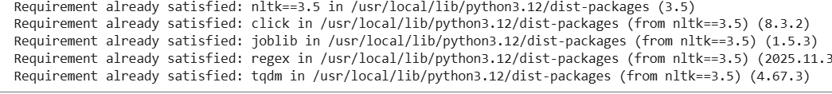
pip install numpy matplotlib
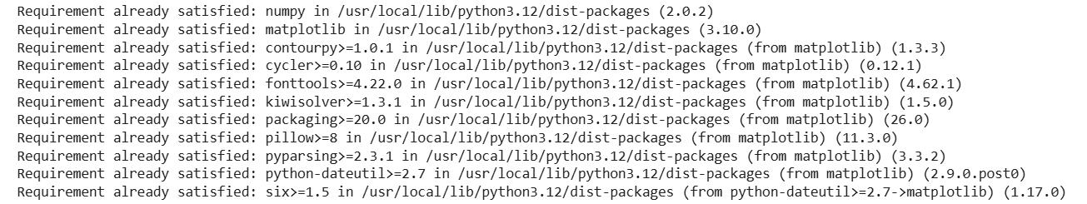
from nltk.tokenize import sent_tokenize, word_tokenize
import nltk
nltk.download('punkt')

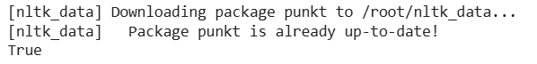

example_string = """Muad'Dib learned rapidly because his first training was in how to learn.
And the first lesson of all was the basic trust that he could learn.
It's shocking to find how many people do not believe they can learn,
and how many more believe learning to be difficult."""
sent_tokenize(example_string)

nltk.download("stopwords")
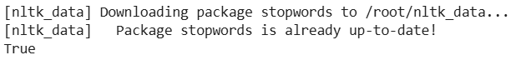
from nltk.corpus import stopwords
from nltk.tokenize import word_tokenize
worf_quote = "Sir, I protest. I am not a merry man!"
words_in_quote = word_tokenize(worf_quote)
words_in_quote
stop_words = set(stopwords.words("english"))
filtered_list = []
for word in words_in_quote:
if word.casefold() not in stop_words:
filtered_list.append(word)
print(filtered_list)
from nltk.stem import PorterStemmer
from nltk.tokenize import word_tokenize
stemmer = PorterStemmer()
string_for_stemming = """
.. The crew of the USS Discovery discovered many discoveries.
... Discovering is what explorers do."""
words = word_tokenize(string_for_stemming)
words
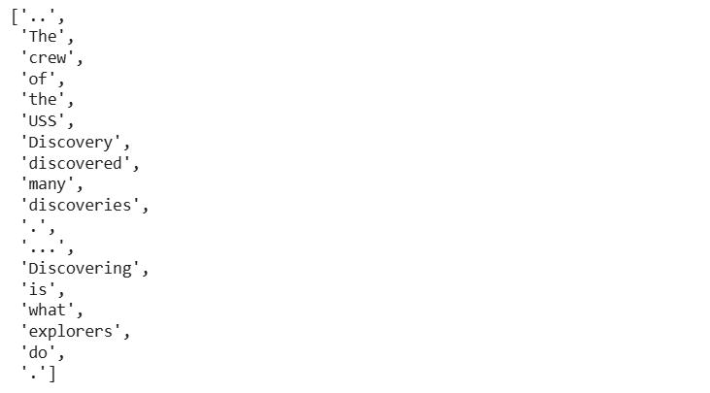
stemmed_words = [stemmer.stem(word) for word in words]
stemmed_words
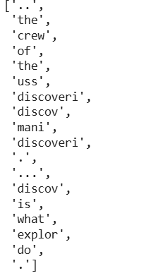
Tagging Parts of Speech

from nltk.tokenize import word_tokenize
import nltk
nltk.download('averaged_perceptron_tagger') # Download the missing resource

sagan_quote = """
If you wish to make an apple pie from scratch,
... you must first invent the universe."""
words_in_sagan_quote = word_tokenize(sagan_quote)
nltk.pos_tag(words_in_sagan_quote)

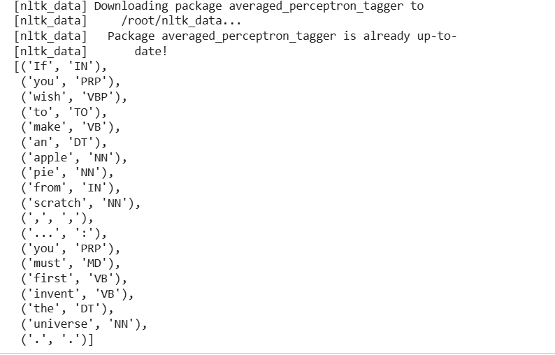
import nltk
nltk.download('averaged_perceptron_tagger')

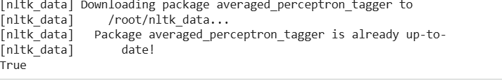
import nltk
nltk.download('tagsets')

nltk.download('tagsets_json')
nltk.help.upenn_tagset()
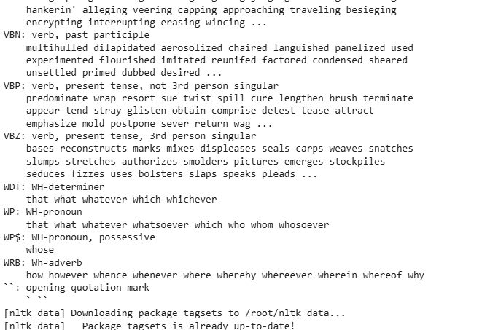

jabberwocky_excerpt = """
... 'Twas brillig, and the slithy toves did gyre and gimble in the wabe:
... all mimsy were the borogoves, and the mome raths outgrabe."""
words_in_excerpt = word_tokenize(jabberwocky_excerpt)

nltk.pos_tag(words_in_excerpt)
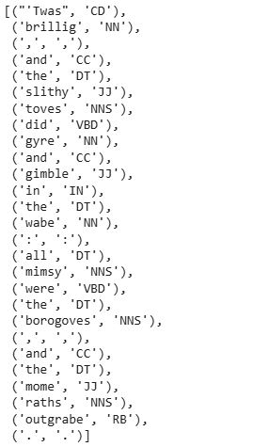

Lemmatizing
from nltk.stem import WordNetLemmatizer
lemmatizer = WordNetLemmatizer()
import nltk
nltk.download('wordnet')
lemmatizer.lemmatize("scarves")

string_for_lemmatizing = "The friends of DeSoto love scarves."
words = word_tokenize(string_for_lemmatizing)
words

lemmatized_words = [lemmatizer.lemmatize(word) for word in words]
lemmatized_words
lemmatizer.lemmatize("worst")

lemmatizer.lemmatize("worst", pos="a")
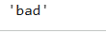

from nltk.tokenize import word_tokenize
lotr_quote = "It's a dangerous business, Frodo, going out your door."
words_in_lotr_quote = word_tokenize(lotr_quote)
words_in_lotr_quote
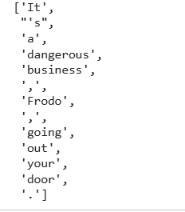

nltk.download("averaged_perceptron_tagger")
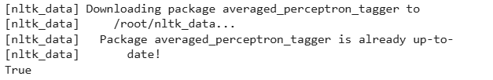

lotr_pos_tags = nltk.pos_tag(words_in_lotr_quote)
lotr_pos_tags
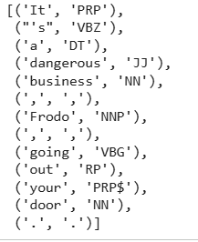

grammar = "NP: {<DT>?<JJ>*<NN>}"
chunk_parser = nltk.RegexpParser (grammar)
tree = chunk_parser.parse(lotr_pos_tags)
tree.pretty_print()
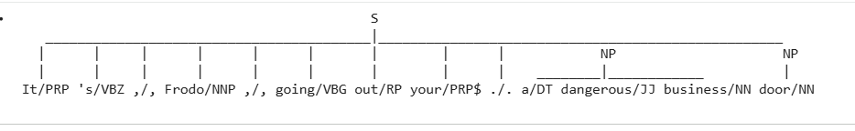

lotr_pos_tags

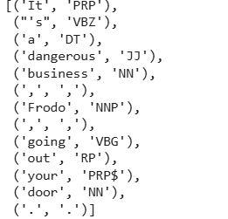
grammar = r"""Chunk: {<.*>+} # Chunk everything
}<JJ>{ # Exclude Adjectives
"""
chunk_parser = nltk.RegexpParser(grammar)
tree = chunk_parser.parse(lotr_pos_tags)
tree.pretty_print()
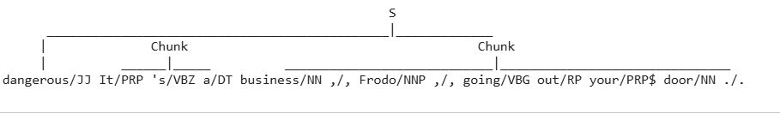

Using Named Entity Recognition (NER)

nltk.download("maxent_ne_chunker")
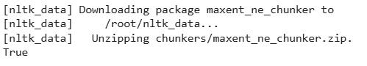

nltk.download("words")
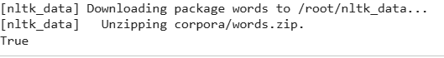
tree = nltk.ne_chunk(lotr_pos_tags)

import nltk
from nltk.tokenize import word_tokenize

nltk.download('punkt')
nltk.download('averaged_perceptron_tagger')
nltk.download('maxent_ne_chunker')
nltk.download('words')
# nltk.download('maxent_ne_chunker_tab') # Previously added, but might not be strictly necessary for this use-case
# nltk.download('punkt_tab') # Removed as it might be causing lookup confusion

# Re-define necessary variables for 'tree' within this cell
lotr_quote = "It's a dangerous business, Frodo, going out your door."
words_in_lotr_quote = word_tokenize(lotr_quote)
lotr_pos_tags = nltk.pos_tag(words_in_lotr_quote);

# Define 'tree' before its first use
tree = nltk.ne_chunk(lotr_pos_tags)
tree.pretty_print()

tree = nltk.ne_chunk (lotr_pos_tags, binary=True)
tree.pretty_print()

Iquote = """Men like Schiaparelli watched the red planet-it is odd, by-the-bye, that
for countless centuries Mars has been the star of war-but failed to
interpret the fluctuating appearances of the markings they mapped so well.
All that time the Martians must have been getting ready.
During the opposition of 1894 a great light was seen on the illuminated
part of the disk, first at the Lick Observatory, then by Perrotin of Nice,
and then by other observers. English readers heard of it first in the
issue of Nature dated August 2."""

def extract_ne(quote):
words = word_tokenize(quote, language="english") # Changed to lowercase 'english'
tags = nltk.pos_tag(words)
tree = nltk.ne_chunk(tags, binary=True)
return set("".join(i[0] for i in t.leaves()) for t in tree if hasattr(t, "label") and t.label() == "NE")

extract_ne(Iquote)
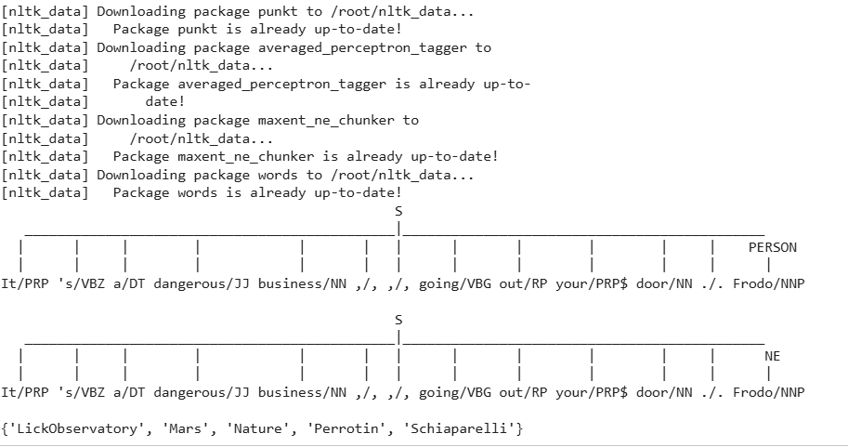
Getting Text to Analyze

nltk.download("book")
from nltk.book import *
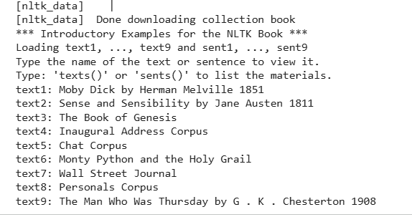
Using a Concordance

text8.concordance("man")
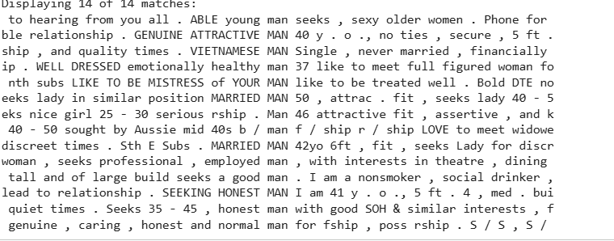
text8.concordance("woman")
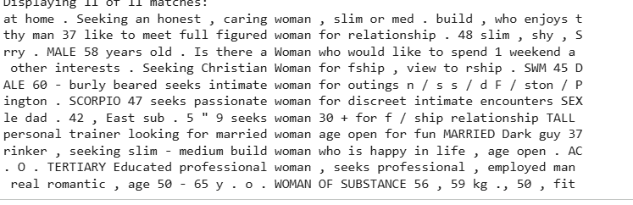
Making a Dispersion Plot

text8.dispersion_plot(
["woman", "lady", "girl", "gal", "man", "gentleman", "boy", "guy"]
)

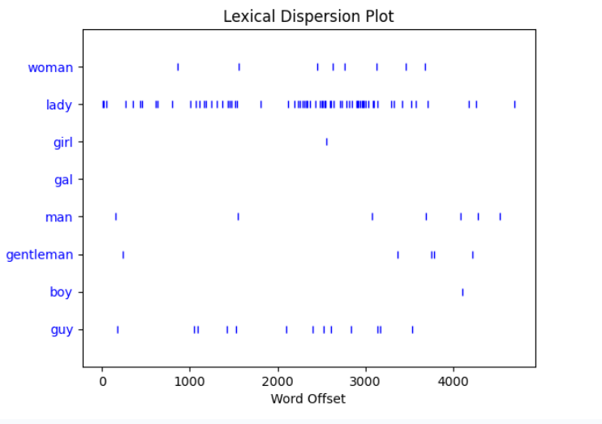
text2.dispersion_plot(["Allenham", "Whitwell", "Cleveland", "Combe"])
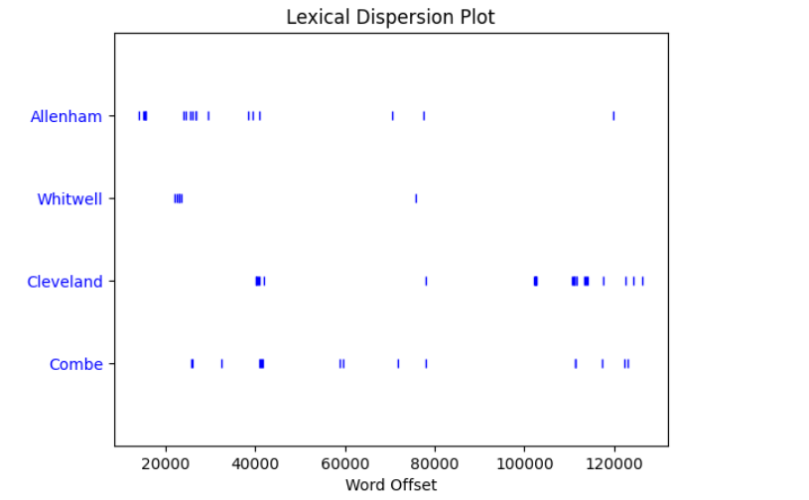
Making a Frequency Distribution
from nltk import FreqDist
frequency_distribution = FreqDist(text8)
print(frequency_distribution)
frequency_distribution.most_common(20)
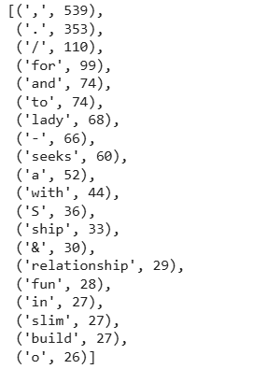

from nltk.corpus import stopwords
import nltk

stop_words = set(stopwords.words("english"))

meaningful_words = [
word for word in text8 if word.casefold() not in stop_words
]
frequency_distribution.most_common(20)
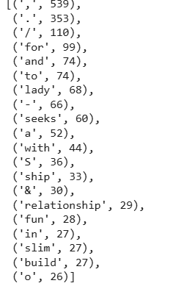

Finding Collocations
text8.collocations()
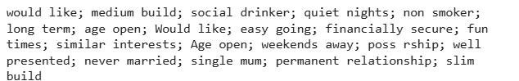

from nltk.stem import WordNetLemmatizer
import nltk
lemmatizer = WordNetLemmatizer()
lemmatized_words = [lemmatizer.lemmatize(word) for word in text8]
new_text = nltk.Text(lemmatized_words)
new_text.collocations()
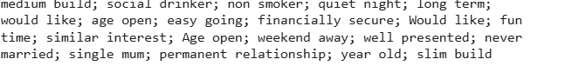

EXPERIMENT-2
Sentence Detection

pip install spacy
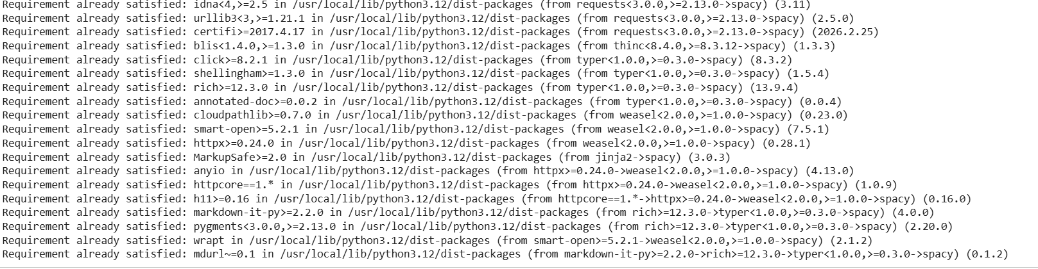

import spacy
nlp = spacy.load("en_core_web_sm")
nlp

introduction_doc = nlp("This tutorial is about Natural Language Processing in")
type(introduction_doc)

[token.text for token in introduction_doc]

import pathlib
file_name = "Introduction.txt.txt"
introduction_doc = nlp(pathlib.Path(file_name).read_text(encoding="utf-8"))
print ([token.text for token in introduction_doc])

Sentence Detection

about_text = """Gus Proto is a Python developer currently working for a London-based Fintech company. He is interested in Natural Language Processing."""
about_doc = nlp(about_text)
sentences = list(about_doc.sents)
len(sentences)

for sentence in sentences:
print(f"{sentence[:5]}...")
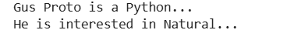

ellipsis_text = """Gus, can you, ... never mind, I forgot ... what I was saying. So, do you think we should ..."""
from spacy.language import Language
@Language.component("set_custom_boundaries")
def set_custom_boundaries (doc):
for token in doc[:-1]:
if token.text == "...":
doc [token.i + 1].is_sent_start = True
return doc
custom_nlp = spacy.load("en_core_web_sm")
custom_nlp.add_pipe("set_custom_boundaries", before="parser")

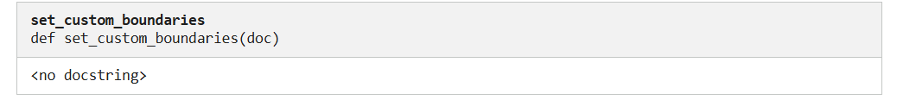
custom_ellipsis_doc = custom_nlp(ellipsis_text)
custom_ellipsis_sentences = list(custom_ellipsis_doc.sents)
custom_ellipsis_sentences = list(custom_ellipsis_doc.sents)
for sentence in custom_ellipsis_sentences:
print(sentence)

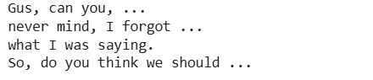
Tokens in spaCy

import spacy
nlp = spacy.load("en_core_web_sm")
about_text = (
"Gus Proto is a Python developer currently"
" working for a London-based Fintech"
" company. He is interested in learning"
" Natural Language Processing."
)
about_doc = nlp(about_text)
for token in about_doc:
print (token, token.idx)

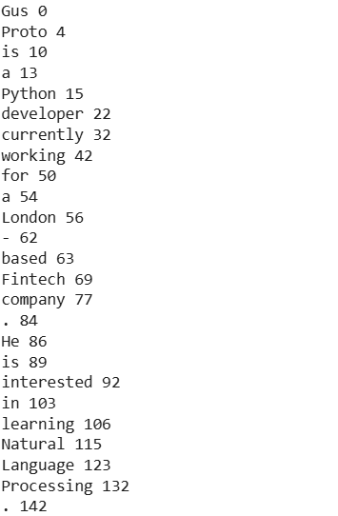
print(
f'{"Text with Whitespace":22}'
f'{"Is Alphanumeric?":15}'
f'{"Is Punctuation?":18}'
f'{"Is Stop Word?"}')

for token in about_doc:
print(
f'{str(token.text_with_ws):22}'
f'{str(token.is_alpha):15}'
f'{str(token.is_punct):18}'
f'{str(token.is_stop)}'
)

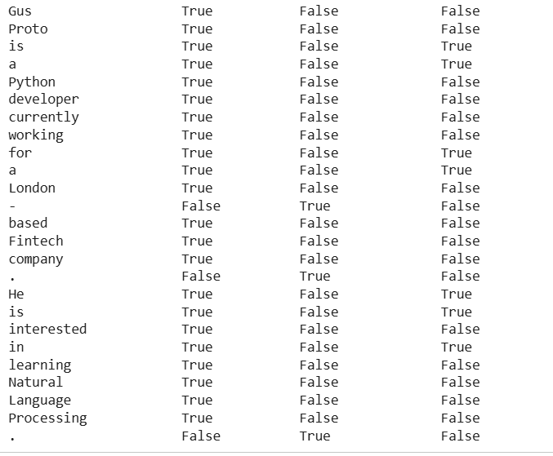

custom_about_text = (
"Gus Proto is a Python developer currently"
" working for a London-based Fintech"
" company. He is interested in learning"
" Natural Language Processing."
)
tokens_to_print = [token.text for token in about_doc[8:15]]
print(tokens_to_print)

import re
import spacy
from spacy.tokenizer import Tokenizer
custom_nlp = spacy.load("en_core_web_sm")
prefix_re = spacy.util.compile_prefix_regex(custom_nlp.Defaults.prefixes)
suffix_re = spacy.util.compile_suffix_regex(custom_nlp.Defaults.suffixes)
custom_infixes = [r"@"]
infix_re = spacy.util.compile_infix_regex(
list(custom_nlp.Defaults.infixes) + custom_infixes
)
custom_nlp.tokenizer = Tokenizer(
custom_nlp.vocab,
prefix_search=prefix_re.search,
suffix_search=suffix_re.search,
infix_finditer=infix_re.finditer,
token_match=None,
)
custom_about_text = (
"Gus Proto is a Python developer currently"
" working for a London@based Fintech"
" company. He is interested in learning"
" Natural Language Processing."
)
custom_tokenizer_about_doc = custom_nlp(custom_about_text)
print([token.text for token in custom_tokenizer_about_doc[8:15]])
Stop Words

import spacy
spacy_stopwords = spacy.lang.en.stop_words.STOP_WORDS
len(spacy_stopwords)
for stop_word in list(spacy_stopwords)[:10]:
print(stop_word)
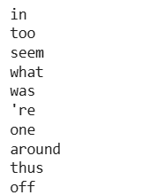

import spacy
custom_about_text = (
"Gus Proto is a Python developer currently"
" working for a London-based Fintech"
" company. He is interested in learning"
" Natural Language Processing."
)
nlp = spacy.load("en_core_web_sm")
about_doc = nlp(custom_about_text)
filtered_tokens = [token.text for token in about_doc if not token.is_stop]
print(filtered_tokens)
Lemmatization

import spacy
nlp = spacy.load("en_core_web_sm")
conference_help_text = (
"Gus is helping organize a developer"
" conference on Applications of Natural Language"
"Processing. He keeps organizing local Python meetups"
" and several internal talks at his workplace."
)
conference_help_doc = nlp(conference_help_text)
for token in conference_help_doc:
if str(token) != str(token.lemma_):
print(f"{str(token):>20} : {str(token.lemma_)}")
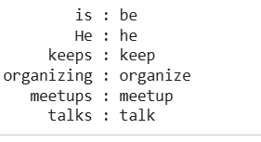

Word Frequency

import spacy
from collections import Counter
nlp = spacy.load("en_core_web_sm")
complete_text = """Gus Proto is a Python developer currently working for a London-based Fintech company. He is interested in learning Natural Language Processing.
There is a developer conference happening on 21 July 2019 in London. It is titled "Applications of Natural Language Processing". There is a helpline number available at +44-1234567891. Gus is helping organize it.
He keeps organizing local Python meetups and several internal talks at his workplace. Gus is also presenting a talk. The talk will introduce the reader about "Use cases of Natural Language Processing in Fintech".
Apart from his work, he is very passionate about music. Gus is learning to play the Piano. He has enrolled himself in the weekend batch of Great Piano Academy.
Great Piano Academy is situated in Mayfair or the City of London and has world-class piano instructors."""
complete_doc = nlp(complete_text)
words = [
token.text
for token in complete_doc
if not token.is_stop and not token.is_punct
]
print(Counter(words).most_common(5))

Counter(
[token.text for token in complete_doc if not token.is_punct]
).most_common(5)

Part-of-Speech Tagging

import spacy
nlp = spacy.load("en_core_web_sm")
about_text = (
"Gus Proto is a Python developer currently"
" working for a London-based Fintech"
" company. He is interested in learning" # Added missing opening quote
" Natural Language Processing."
)
about_doc = nlp(about_text)
for token in about_doc:
print(
f"""TOKEN: {str(token)}
TAG: {str(token.tag_):10} POS: {token.pos_}
EXPLANATION: {spacy.explain(token.tag_)}"""
)

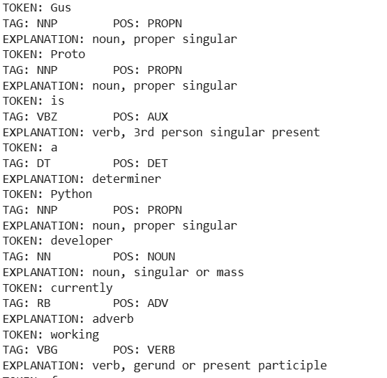
nouns = []
adjectives = []
for token in about_doc:
if token.pos_ == "NOUN":
nouns.append(token)
if token.pos_ == "ADJ":
adjectives.append(token)
nouns
adjectives
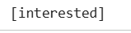
Visualization: Using displaCy

import spacy
from spacy import displacy
nlp = spacy.load("en_core_web_sm")
about_interest_text = "He is interested in learning Natural Language Processing"
about_interest_doc = nlp(about_interest_text)
# Generate HTML code for the dependency parse tree
html_code = displacy.render(about_interest_doc, style="dep", options={"distance": 120})
# Print or save the HTML code as needed
print(html_code)

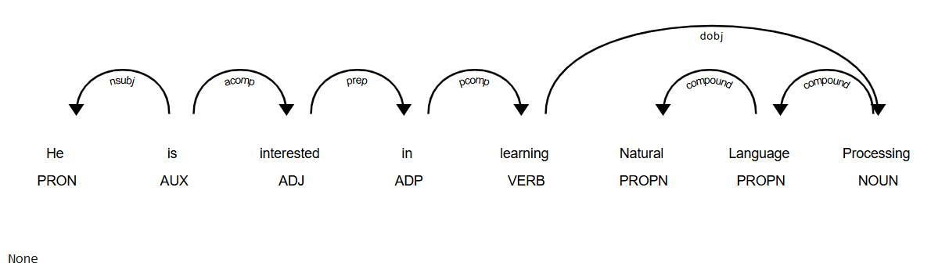
Preprocessing Functions
import spacy
nlp = spacy.load("en_core_web_sm")
complete_text = """Gus Proto is a Python developer currently
working for a London-based Fintech company. He is
interested in learning Natural Language Processing.
There is a developer conference happening on 21 July
2019 in London. It is titled "Applications of Natural
Language Processing". There is a helpline number
available at +44-1234567891. Gus is helping organize it.
He keeps organizing local Python meetups and several
internal talks at his workplace. Gus is also presenting
a talk. The talk will introduce the reader about "Use
cases of Natural Language Processing in Fintech".
Apart from his work, he is very passionate about music.
Gus is learning to play the Piano. He has enrolled
himself in the weekend batch of Great Piano Academy.
Great Piano Academy is situated in Mayfair or the City
of London and has world-class piano instructors."""
complete_doc = nlp(complete_text)
def is_token_allowed(token):
return bool(
token
and str(token).strip()
and not token.is_stop
and not token.is_punct
)
def preprocess_token(token):
return token.lemma_.strip().lower()
complete_filtered_tokens = [
preprocess_token(token)
for token in complete_doc
if is_token_allowed(token)
]
print(complete_filtered_tokens)

Rule-Based Matching Using spaCy
import spacy
nlp = spacy.load("en_core_web_sm")
about_text = (
"Gus Proto is a Python developer currently"
" working for a London-based Fintech"
" company. He is interested in learning"
" Natural Language Processing."
)
about_doc = nlp(about_text)
from spacy.matcher import Matcher
matcher = Matcher(nlp.vocab)
def extract_full_name(nlp_doc):
pattern = [{"POS": "PROPN"}, {"POS": "PROPN"}]
matcher.add("FULL_NAME", [pattern])
matches = matcher(nlp_doc)
for _,start, end in matches:
span = nlp_doc[start:end]
yield span.text
# Print the extracted full name
print(next(extract_full_name(about_doc)))
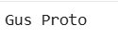
Dependency Parsing Using spaCy

import spacy
nlp = spacy.load("en_core_web_sm")
one_line_about_text = (
"Gus Proto is a Python developer"
" currently working for a London-based Fintech company"
)
one_line_about_doc = nlp(one_line_about_text)
# Extract children of `developer
print([token.text for token in one_line_about_doc[5].children])
# Extract previous neighboring node of `developer
print(one_line_about_doc[5].nbor(-1))
# Extract next neighboring node of ` developer
print(one_line_about_doc[5].nbor())
# Extract all tokens on the left of `developer
print([token.text for token in one_line_about_doc[5].lefts])
# Extract tokens on the right of `developer
print([token.text for token in one_line_about_doc[5].rights])
# Print subtree of`developer
print(list(one_line_about_doc[5].subtree))

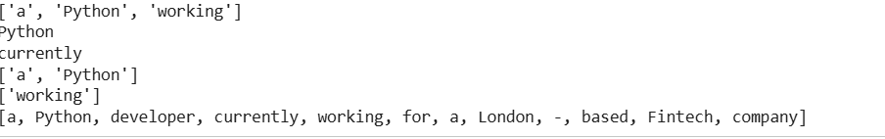
import spacy
nlp = spacy.load("en_core_web_sm")
piano_text = "Gus is learning piano"
piano_doc = nlp(piano_text)
for token in piano_doc:
print(
f"""
TOKEN: {token.text}
{token.tag_ =}
{token.head.text =}
{token.dep_ =}"""
)

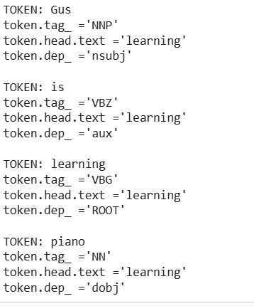
displacy.serve(piano_doc, style="dep")
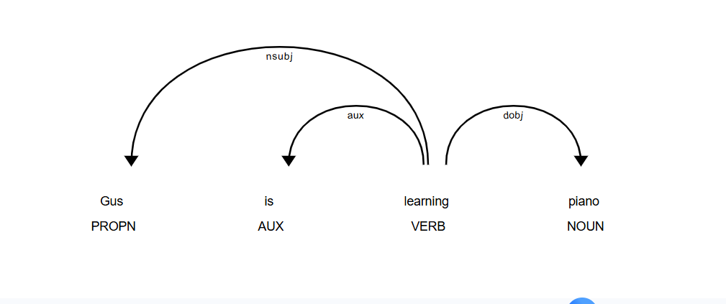

import spacy

nlp = spacy.load("en_core_web_sm")
one_line_about_text = (
"Gus Proto is a Python developer"
" currently working for a London-based Fintech company"
)
one_line_about_doc = nlp(one_line_about_text)
# Extract children of `developer
print([token.text for token in one_line_about_doc[5].children])
# Extract previous neighboring node of `developer
print(one_line_about_doc[5].nbor(-1))
# Extract next neighboring node of ` developer
print(one_line_about_doc[5].nbor())
# Extract all tokens on the left of `developer
print([token.text for token in one_line_about_doc[5].lefts])
# Extract tokens on the right of `developer
print([token.text for token in one_line_about_doc[5].rights])
# Print subtree of`developer
print(list(one_line_about_doc[5].subtree))
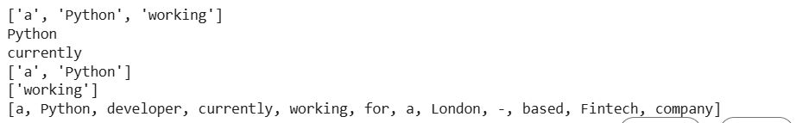
Named-Entity Recognition
import spacy
nlp = spacy.load("en_core_web_sm")
piano_class_text = (
"Great Piano Academy is situated"
" in Mayfair or the City of London and has"
"world-class piano instructors."
)
piano_class_doc = nlp(piano_class_text)
for ent in piano_class_doc.ents:
print(
f"""
{ent.text =}
{ent.start_char =}
{ent.end_char =}
{ent.label_ =}
spacy.explain('{ent.label_}') = {spacy.explain(ent.label_)}"""
)

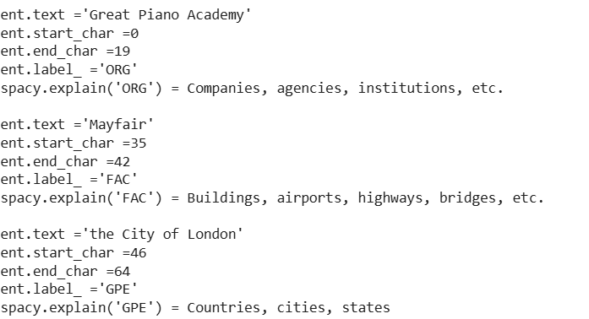
displacy.serve(piano_class_doc, style="ent")

survey_text = """Out of 5 people surveyed, James Robert,
Julie Fuller and Benjamin Brooks like
apples. Kelly Cox and Matthew Evans
like oranges."""
def replace_person_names(token):
if token.ent_iob != 0 and token.ent_type_ == "PERSON":
return "[REDACTED] "
return token.text_with_ws
def redact_names(nlp_doc):
with nlp_doc.retokenize() as retokenizer:
for ent in nlp_doc.ents:
retokenizer.merge(ent)
tokens = map(replace_person_names, nlp_doc)
return "".join(tokens)
survey_doc = nlp(survey_text)
print(redact_names(survey_doc))
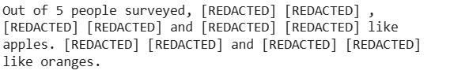

EXPERIMENT-3
One-Hot Encoding

import numpy as np
# Step 1: Convert Text to Lower case
text = "My Name is AKilesh"
text_lower = text.lower()
# Step 2: Tokenize the text
tokens = text_lower.split()
# Step 3: Get unique words
unique_words = set (tokens)
# Step 4: Sort the word List
sorted_words = sorted(unique_words)
# Step 5: Get the integer/position of the words
word_to_index = {word: index for index, word in enumerate(sorted_words)}
# Step 6 and 7: Create one-hot vectors and matrix
one_hot_matrix = np.zeros((len(tokens), len(unique_words)))
for i, token in enumerate(tokens):
word_index = word_to_index[token]
one_hot_matrix[i, word_index] = 1
# Display the results
print("Original Text:", text)
print("One-Hot Matrix:")
print(one_hot_matrix)
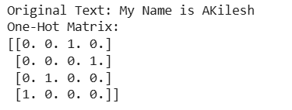

Bag of Words

from sklearn.feature_extraction.text import CountVectorizer
# Example Sentences
sentence1 = "My Name is AKilesh"
sentence2 = "I am a student at AVV chennai"
# Step 1: Convert to Lowercase
sentence1 = sentence1.lower()
sentence2 = sentence2.lower()
#
#
# Step 2: Remove special characters and stopwords (optional)
# In this example, we'll skip this step for simplicity.
# Step 3: Create a list of sentences
corpus = [sentence1, sentence2]
# Step 4: Use CountVectorizer to create Bag of Words model
vectorizer = CountVectorizer()
X = vectorizer.fit_transform(corpus)
# Display the vocabulary and the Bag of Words matrix
print("Vocabulary:", vectorizer.get_feature_names_out())
print("Bag of Words Matrix:")
print(X.toarray())

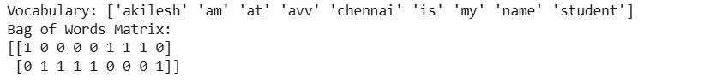
import pandas as pd
import numpy as nd
# Construct a small corpus
corpus = ['data science is one of the most important fields of science',
'this is one of the best data science courses',
'data scientists analyze data']
# Create a word set for the corpus
words_set = set()
for doc in corpus:
words = doc.split() # Fixed: Changed from split('') to split() for proper word tokenization
words_set = words_set.union(set(words))
print('Number of words in the corpus:', len(words_set))
print('The words in the corpus:\n', words_set)
# Computing Term Frequency (TF)
n_docs = len(corpus)
n_words_set = len(words_set)
df_tf = pd.DataFrame(np.zeros((n_docs, n_words_set)), columns=list(words_set))
# Compute Term Frequency (TF)
for i in range(n_docs):
words = corpus[i].split(' ') # Words in the document
for w in words:
df_tf.loc[i, w] = df_tf.loc[i, w] + (1 / len(words)) # Fixed: Using .loc to avoid ChainedAssignmentError
print("Term Frequency (TF):")
print(df_tf)
# Computing Inverse Document Frequency (IDF)
print("\nInverse Document Frequency (IDF):")
idf = {}
for w in words_set: # Fixed: Corrected typo from words _set to words_set
k = 0 # number of documents in the corpus that contain this word
for i in range(n_docs):
if w in corpus[i].split():
k += 1
idf[w] = np.log10(n_docs / k)
print(f'{w:>15}: {idf[w]:>10}.') # Fixed: Removed unclosed parenthesis
# Putting it Together: Computing TF-IDF
df_tf_idf = df_tf.copy()
for w in words_set:
for i in range(n_docs):
df_tf_idf.loc[i, w] = df_tf.loc[i, w] * idf[w] # Fixed: Using .loc to avoid ChainedAssignmentError
print("\nTF-IDF:")
print(df_tf_idf)
# Removed: 'localhost:8888/notebooks/Downloads/NLP' was not valid Python code

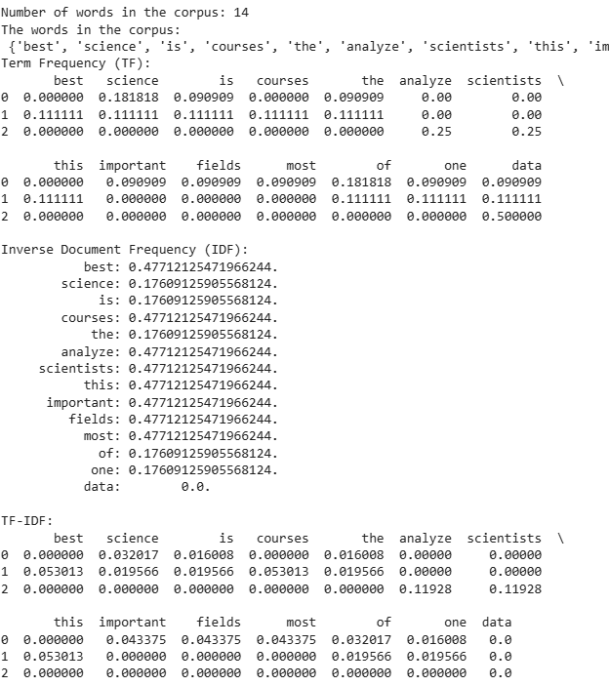
WORD2VEC

pip install gensim
import gensim
from gensim.models import KeyedVectors
import gensim.downloader as api
# DownLoad the pre-trained Word2Vec model from Google (takes some time)
# This downloads a large file, so be patient.
word2vec_model_path = api.load("word2vec-google-news-300", return_path=True)
# Load the Word2Vec model using gensim
word2vec_model = gensim.models.KeyedVectors.load_word2vec_format(word2vec_model_path, binary=True)
# Example: Get the word embedding for the word "king"
word_embedding = word2vec_model["king"]
# Print the dimensionality of the word embedding
print("Dimensionality of word embedding:", len(word_embedding))
# Example: Get the most similar words to "king"
similar_words = word2vec_model.most_similar("king")
print("Words most similar to 'king':", similar_words)
# Example: Calculate the similarity between two words
similarity_score = word2vec_model.similarity("king", "queen")
print("Similarity between 'king' and 'queen':", similarity_score)
# Example: Calculate the vector representing the combination of words "king" and "man" minus
result_vector = word2vec_model.most_similar(positive=["king", "man"], negative=["woman"], topn=1)
print("Vector representation of 'king- man + woman':", result_vector)

pip install spacy
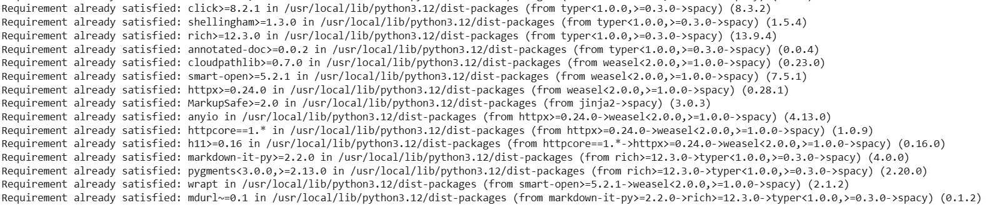

!python -m spacy download en_core_web_md
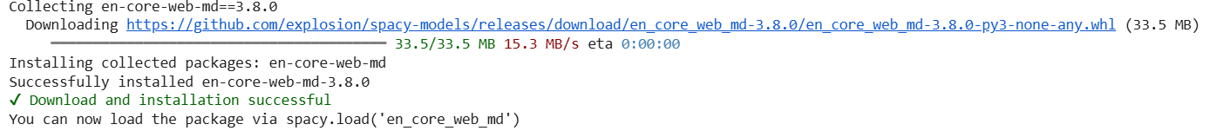

GLOVE

import spacy
# Load the pre-trained GLoVe model
nlp = spacy.load("en_core_web_md")
# Test sentences
sentence1 = "I love natural language processing."
sentence2 = "GloVe is a powerful word embedding technique."
# Tokenize and get word embeddings for each sentence
doc1 = nlp(sentence1)
doc2 = nlp(sentence2) # Fixed: Changed n1p to nlp
# Print word embeddings for each word in the sentences
print("Word embeddings for sentence 1:")
for token in doc1:
print(f"{token.text}: {token.vector}") # Fixed: IndentationError
print("\nWord embeddings for sentence 2:")
for token in doc2:
print(f"{token.text}: {token.vector}") # Fixed: IndentationError

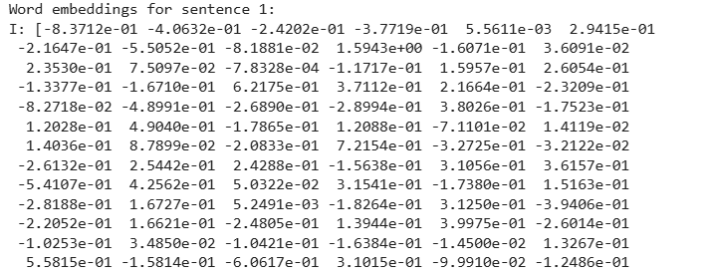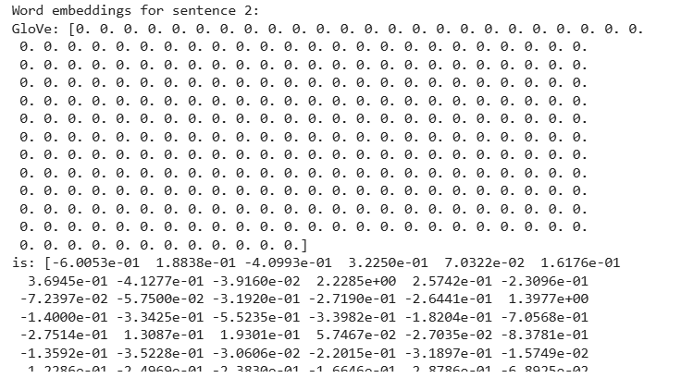

from tensorflow.keras.preprocessing.text import Tokenizer
from tensorflow.keras.preprocessing.sequence import pad_sequences
import numpy as np # Changed ud to np for consistency and correctness

# Define a list of strings as your sample text
x = ['text', 'the', 'leader', 'prime', 'natural', 'language']

# Create the tokenizer
tokenizer = Tokenizer()
tokenizer.fit_on_texts(x)

# Number of unique words in the dictionary
print("Number of unique words in the dictionary =", len(tokenizer.word_index))
print("Dictionary is =", tokenizer.word_index)

# Function to create an embedding matrix for the vocabulary
def embedding_for_vocab(filepath, word_index, embedding_dim):
vocab_size = len(word_index) + 1 # Corrected indentation
# Adding again 1 because of reserved 0 index
embedding_matrix_vocab = np.zeros((vocab_size, embedding_dim))
try:
with open(filepath, encoding="utf8") as f:
for line in f:
word, *vector = line.split()
if word in word_index: # Corrected 'word index' to 'word_index'
idx = word_index[word]
# Ensure the vector has enough elements before slicing
if len(vector) >= embedding_dim:
embedding_matrix_vocab[idx] = np.array(vector, dtype=np.float32)[:embedding_dim] # Corrected slicing and variable
else:
# Handle cases where vector is too short (e.g., fill with zeros or skip)
print(f"Warning: Vector for '{word}' is too short. Skipping or padding with zeros.")

except FileNotFoundError:
print(f"Error: GloVe file '{filepath}' not found. Please ensure it's in the correct directory.")
# Return an empty matrix or handle the error as appropriate for your application
return np.zeros((vocab_size, embedding_dim))

return embedding_matrix_vocab

# Define the embedding dimension
embedding_dim = 100

# Generate the embedding matrix for the given GloVe file
# Note: This will likely fail unless 'glove.6B.100d.txt' is downloaded and in the correct path
embedding_matrix_vocab = embedding_for_vocab('glove.6B.100d.txt', tokenizer.word_index, embedding_dim) # Completed function call

# Print the dense vector for the first word in the vocabulary
# This assumes the embedding matrix was successfully created and populated
if embedding_matrix_vocab.shape[0] > 1:
first_word_in_vocab = list(tokenizer.word_index.keys())[0]
first_word_id = tokenizer.word_index[first_word_in_vocab]
print(f"\nDense vector for '{first_word_in_vocab}':\n{embedding_matrix_vocab[first_word_id]}")
else:
print("Embedding matrix is empty or not properly initialized.")

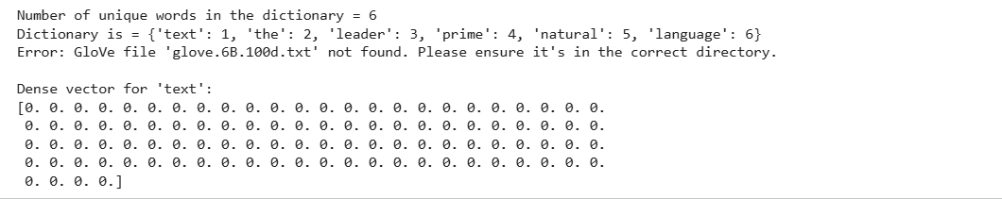

import spacy
import matplotlib.pyplot as plt
from sklearn.manifold import TSNE
import numpy as np # Changed 'up' to 'np'
# Load the pre-trained GloVe model
nlp = spacy.load("en_core_web_md")
# List of words for visualization
words_to_visualize = ["natural", "language", "processing", "GloVe", "powerful", "word", "embeddings"]
# Get word embeddings for the selected words
word_vectors = [nlp(word).vector for word in words_to_visualize]
# Convert word_vectors to a NumPy array
word_vectors_array = np.array(word_vectors)
# Ensure perplexity is less than the number of samples
perplexity = min(30, len(word_vectors_array) - 1)
# Apply t-SNE to reduce dimensionality to 2D
tsne = TSNE(n_components=2, perplexity=perplexity, random_state=42)
word_vectors_2d = tsne.fit_transform(word_vectors_array)
# Plot the words in 2D space
plt.figure(figsize=(8, 8))
plt.scatter(word_vectors_2d[:, 0], word_vectors_2d[:, 1])
# Annotate each point with the corresponding word
for i, word in enumerate(words_to_visualize):
plt.annotate(word, (word_vectors_2d[i, 0], word_vectors_2d[i, 1])) # Fixed indentation
plt.title("t-SNE Visualization of Word Embeddings")
plt.show()

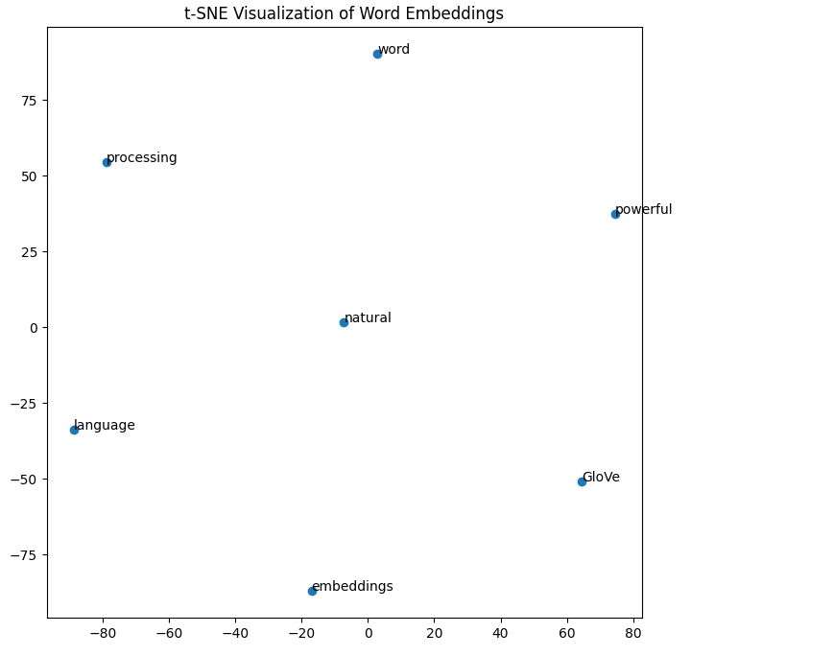
FAST TEXT
!pip install gensim
import nltk
from nltk.tokenize import word_tokenize
from gensim.models import FastText

# Download the 'punkt_tab' resource if not already downloaded
# This is necessary for word_tokenize to function correctly
try:
nltk.data.find('tokenizers/punkt_tab')
except LookupError:
nltk.download('punkt_tab')

# Dummy sentences
sentences = [
"This is a sample sentence for FastText.",
"FastText is a powerful word embedding model.",
"We can train FastText on custom sentences too.",
"Creating a simple example for demonstration.",
"Let's check the similarity of some words."
]
# Tokenize the sentences
tokenized_sentences = [word_tokenize(sentence.lower()) for sentence in sentences]
# Train FastText model
model = FastText(
sentences=tokenized_sentences,
vector_size=128,
window=5,
min_count=1, # Adjust min_count as needed
workers=4,
epochs=10,
sg=1,
seed=42
)
# Save the trained model
model.save('dummy_fasttext_model')
# Access the word vectors
ftext = model.wv
# Check the number of unique words in the model
print("Number of unique words:", len(ftext.index_to_key))
# Check the vector size
print("Vector size:", ftext.vector_size)
# Get the vector for a specific word
word_vector = ftext["fasttext"]
print("Vector for 'fasttext':", word_vector)
# Find similar words
similar_words_mantap = ftext.similar_by_word("mantap", topn=5)
print("Similar words to 'mantap':", similar_words_mantap)
similar_words_bagus = ftext.similar_by_word("bagus", topn=5)
print("Similar words to 'bagus':", similar_words_bagus)

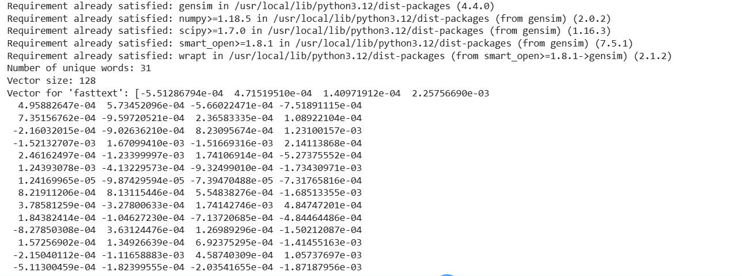
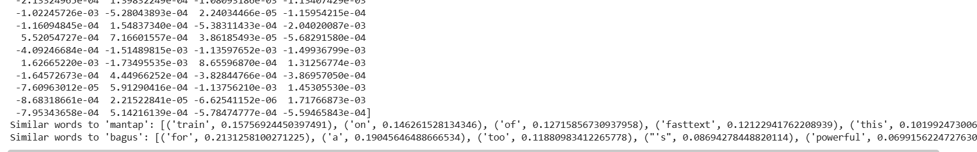

EXPERIMENT-4
N-gram model 1,2,3 gram

BUILDING LANGUAGE MODELS N gram model
def readData():
data = ['This is a dog','This is a cat','I love my cat','This is my name']
dat=[]
for i in range(len(data)):
for word in data[i].split():
dat.append (word)
print(dat)
return dat
def createBigram(data):
listOfBigrams = []
bigramCounts = {}
unigramCounts = {}
for i in range(len(data)-1):
# This condition `if i< len(data) - 1 and data[i+1].islower():` seems problematic for bigram creation.
# It will only create bigrams where the second word starts with a lowercase letter.
# Assuming the intention is to create all bigrams, the `islower()` check might be removed or adjusted.
# For now, I'm keeping it as is, but it's worth reviewing.
if i < len(data) - 1:
listOfBigrams.append((data[i], data[i + 1]))
if (data[i], data[i+1]) in bigramCounts:
bigramCounts[(data[i], data[i + 1])] += 1
else:
bigramCounts[(data[i], data[i + 1])] = 1
if data[i] in unigramCounts:
unigramCounts[data[i]] += 1
else:
unigramCounts[data[i]] = 1
# Add the last word to unigram counts if not already counted
if len(data) > 0 and data[-1] not in unigramCounts:
unigramCounts[data[-1]] = 1
elif len(data) > 0 and data[-1] in unigramCounts:
unigramCounts[data[-1]] += 1

return listOfBigrams, unigramCounts, bigramCounts
def calcBigramProb(listOfBigrams, unigramCounts, bigramCounts):
listOfProb = {}
for bigram in listOfBigrams:
word1 = bigram[0]
word2 = bigram[1]
# Handle potential division by zero if unigram count is 0
if unigramCounts.get(word1, 0) > 0:
listOfProb[bigram] = (bigramCounts.get(bigram, 0))/(unigramCounts.get(word1))
else:
listOfProb[bigram] = 0 # Or handle as appropriate, e.g., NaN, skip
return listOfProb
if __name__ == '__main__': # Fixed typo
data_words = readData() # Changed variable name to avoid conflict, fixed function call
listOfBigrams, unigramCounts, bigramCounts = createBigram(data_words) # Corrected indentation
print("\n All the possible Bigrams are ")
print(listOfBigrams)
print("\n Bigrams along with their frequency ")
print(bigramCounts)
print("\n Unigrams along with their frequency ")
print(unigramCounts)
bigramProb = calcBigramProb(listOfBigrams, unigramCounts, bigramCounts)
print("\n Bigrams along with their probability ")
print (bigramProb)
inputList="This is my cat"
splt=inputList.split()
outputProb1 = 1
bilist=[] # Fixed initialization
# bigrm=[] # This variable was defined but not used. Removed.
for i in range(len(splt) - 1):
if i < len(splt) - 1: # Fixed missing comparison operator
bilist.append((splt[i], splt[i + 1]))
print("\n The bigrams in given sentence are ")
print(bilist)
for i in range(len(bilist)):
if bilist[i] in bigramProb:
outputProb1 *= bigramProb[bilist[i]]
else:
outputProb1 *= 0
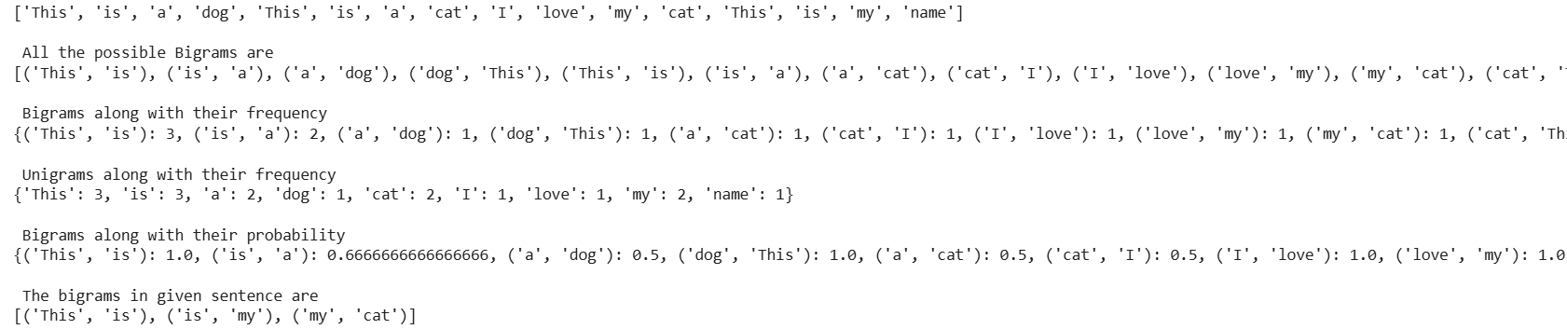

import nltk
nltk.download('punkt_tab')

import nltk
nltk.download('reuters')
from nltk.corpus import reuters
from nltk import bigrams, trigrams
from collections import Counter, defaultdict
# Create a placeholder for model
model = defaultdict(lambda: defaultdict(lambda: 0))
# Count frequency of co-occurancе
for sentence in reuters.sents():
for w1, w2, w3 in trigrams (sentence, pad_right=True, pad_left=True):
model[(w1, w2)][w3] += 1
# Let's transform the counts to probabilities
for w1, w2 in model:
total_count = float(sum(model[(w1, w2)].values()))
for w3 in model[(w1, w2)]:
model[(w1, w2)][w3] /= total_count
dict(model["today", "the"])

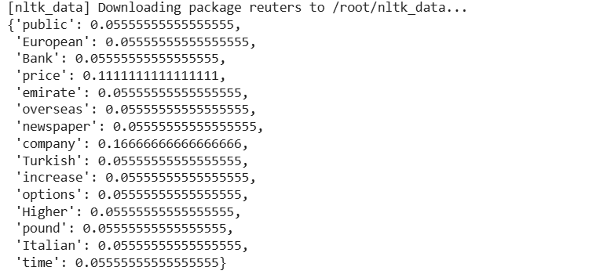
import random
# starting words
text = ["today", "the"]
sentence_finished = False
while not sentence_finished:
# select a random probability threshold
r = random.random()
accumulator = 0.0
for word in model[tuple(text[-2:])].keys():
accumulator += model[tuple(text[-2:])][word]
# select words that are above the probability threshold
if accumulator >= r:
text.append(word)
break
if text[-2:] == [None, None]:
sentence_finished = True
print (' '.join([t for t in text if t]))

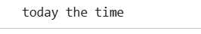
import numpy as np
import pandas as pd
from keras.utils import to_categorical
from keras.preprocessing.sequence import pad_sequences
from keras.models import Sequential
from keras.layers import LSTM, Dense, GRU, Embedding
from keras.callbacks import EarlyStopping, ModelCheckpoint
data_text = """The unanimous Declaration of the thirteen united States of America, When in
We hold these truths to be self-evident, that all men are created equal, that they are endo
He has refused his Assent to Laws, the most wholesome and necessary for the public good.
He has forbidden his Governors to pass Laws of immediate and pressing importance, unless su
He has refused to pass other Laws for the accommodation of large districts of people, unles:
He has called together legislative bodies at places unusual, uncomfortable, and distant fror
He has dissolved Representative Houses repeatedly, for opposing with manly firmness his inva
He has refused for a long time, after such dissolutions, to cause others to be elected; whe
He has endeavoured to prevent the population of these States; for that purpose obstructing
He has obstructed the Administration of Justice, by refusing his Assent to Laws for establi:
He has made Judges dependent on his Will alone, for the tenure of their offices, and the am
He has erected a multitude of New Offices, and sent hither swarms of Officers to harrass ou
He has kept among us, in times of peace, Standing Armies without the Consent of our legisla
He has affected to render the Military independent of and superior to the Civil power.
He has combined with others to subject us to a jurisdiction foreign to our constitution, and
For Quartering large bodies of armed troops among us:
For protecting them, by a mock Trial, from punishment
For cutting off our Trade with all parts of the world:
For imposing Taxes on us without our Consent:
for any Murders which they should comr
For depriving us in many cases, of the benefits of Trial by Jury:
For transporting us beyond Seas to be tried for pretended offences
For abolishing the free System of English Laws in a neighbouring Province, establishing the
For taking away our Charters, abolishing our most valuable Laws, and altering fundamentally
For suspending our own Legislatures, and declaring themselves invested with power to legisl
He has abdicated Government here, by declaring us out of his Protection and waging War agai
He has plundered our seas, ravaged our Coasts, burnt our towns, and destroyed the lives of
He is at this time transporting large Armies of foreign Mercenaries to compleat the works
He has constrained our fellow Citizens taken Captive on the high Seas to bear Arms against
He has excited domestic insurrections amongst us, and has endeavoured to bring on the inhab:
In every stage of these Oppressions We have Petitioned for Redress in the most humble terms
Nor have We been wanting in attentions to our Brittish brethren. We have warned them from
We, therefore, the Representatives of the united States of America, in General Congress, As"""
import re
def text_cleaner(text):
# Lower case text
newString = text.lower()
newString = re.sub(r"'s\b","",newString)
# remove punctuations
newString = re.sub("[^a-zA-Z]", " ", newString)
long_words=[]
# remove short word
for i in newString.split():
if len(i)>=3:
long_words.append(i)
return (" ".join(long_words)).strip()
# preprocess the text
data_new = text_cleaner(data_text)

def create_seq(text):
length = 30
sequences = list()
for i in range(length, len(text)):
# select sequence of tokens
seq = text[i-length:i+1]
# store
sequences.append(seq)
print('Total Sequences: %d' % len(sequences))
return sequences
# create sequences
sequences = create_seq(data_new)

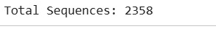
chars = sorted(list(set(data_new)))
mapping = dict((c, i) for i, c in enumerate(chars))
def encode_seq(seq):
sequences = list()
for line in seq:
# integer encode Line
encoded_seq = [mapping [char] for char in line]
# store
sequences.append (encoded_seq)
return sequences
# encode the sequences
sequences = encode_seq(sequences)
def encode_seq(seq, mapping):
encoded_seqs = []
for line in seq:
# integer encode Line
encoded_seq = [mapping[char] for char in line]
# store
encoded_seqs.append(encoded_seq)
return np.array(encoded_seqs)
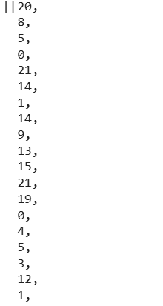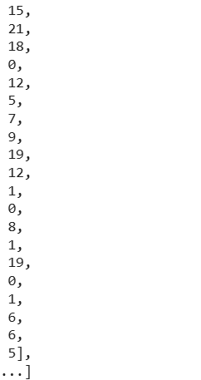

vocab = len(mapping)
sequences = np.array(sequences)
X, y = sequences[:, :-1], sequences[:, -1]
# one hot encode y
y = to_categorical(y, num_classes=vocab)

from sklearn.model_selection import train_test_split
# vocabulary size
vocab = len(mapping)
sequences = np.array (sequences)
# create X and y
# create train and validation sets
X_tr, X_val, y_tr, y_val = train_test_split(X, y, test_size=0.1, random_state=42)
print('Train shape:', X_tr.shape, 'Val shape:', X_val.shape)

from sklearn.model_selection import train_test_split
from keras.utils import to_categorical
import numpy as up
# Assuming you have a 'mapping' variable defined elsewhere
# vocab = Len(mapping)
# Assuming you have a 'sequences' variable defined elsewhere
# sequences = np.array(sequences)
# Reshape sequences to make it 2-dimensional
sequences = sequences.reshape((len(sequences), sequences.shape[1]))
# create X and y
X, y = sequences[:, :-1], sequences[:, -1]
# one hot encode y
y = to_categorical(y, num_classes=vocab)
# create train and validation sets
X_tr, X_val, y_tr, y_val = train_test_split(X, y, test_size=0.1, random_state=42)
print('Train shape:', X_tr.shape, 'Val shape:', X_val.shape)

model = Sequential()
model.add(Embedding(vocab, 50, input_length=30, trainable=True))
model.add(GRU(150, recurrent_dropout=0.1, dropout=0.1))
model.add(Dense(vocab, activation='softmax'))
print(model.summary())
# compile the model
model.compile(loss='categorical_crossentropy', metrics=['acc'], optimizer='adam')
# fit the model
model.fit(X_tr, y_tr, epochs=100, verbose=2, validation_data=(X_val, y_val))
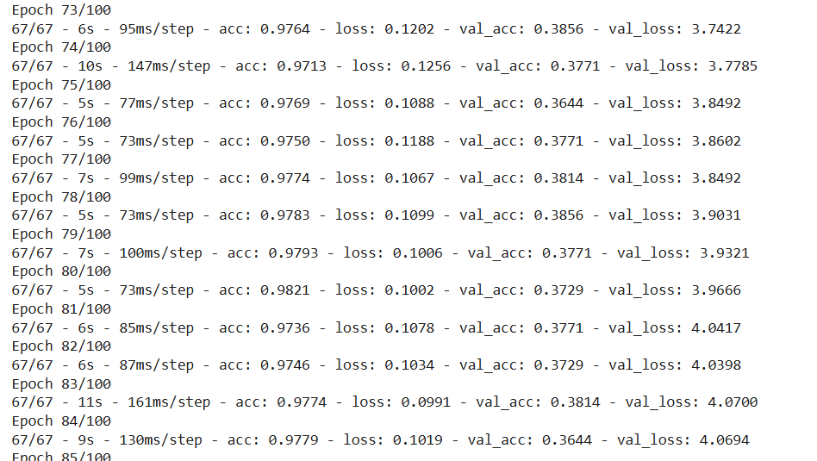
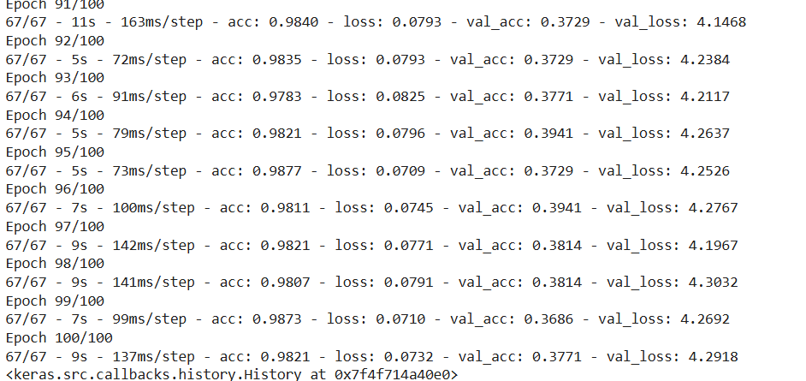

import numpy as np
from keras.preprocessing.sequence import pad_sequences

def generate_seq(model, mapping, seq_length, seed_text, n_chars):
in_text = seed_text
# generate a fixed number of characters
for _ in range(n_chars):
# encode the characters as integers
encoded = [mapping[char] for char in in_text]
# truncate sequences to a fixed length
encoded = pad_sequences([encoded], maxlen=seq_length, truncating='pre')
# predict character probabilities
yhat_probs = model.predict(encoded, verbose=0)
# get the index of the character with the highest probability
yhat = np.argmax(yhat_probs)

# reverse map integer to character
out_char = '' # Fixed unterminated string literal
for char_key, index_val in mapping.items():
if index_val == yhat:
out_char = char_key
break
# append to input
in_text += out_char
return in_text

import numpy as np
from keras.preprocessing.sequence import pad_sequences

def generate_seq(model, mapping, seq_length, seed_text, n_chars):
in_text = seed_text
# generate a fixed number of characters
for _ in range(n_chars):
# encode the characters as integers
encoded = [mapping[char] for char in in_text]
# truncate sequences to a fixed length
encoded = pad_sequences([encoded], maxlen=seq_length, truncating='pre')
# predict character probabilities
yhat_probs = model.predict(encoded, verbose=0)
# get the index of the character with the highest probability
yhat = np.argmax(yhat_probs)

# reverse map integer to character
out_char = ''
for char_key, index_val in mapping.items():
if index_val == yhat:
out_char = char_key
break
# append to input
in_text += out_char
return in_text

inp='Large armies of'
print(len(inp))
print(generate_seq(model,mapping, 50, inp.lower(),15))
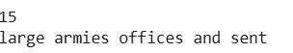

EXPERIMENT-5
Tokenization
import nltk
from nltk.tokenize import word_tokenize
nltk.download('punkt') # Ensure 'punkt_tab' tokenizer is downloaded
nltk.download('punkt_tab') # Download the 'punkt_tab' resource
nltk.download('averaged_perceptron_tagger_eng') # Download the POS tagger
text = word_tokenize("And now for something completely different")
tags = nltk.pos_tag(text)
print(tags)
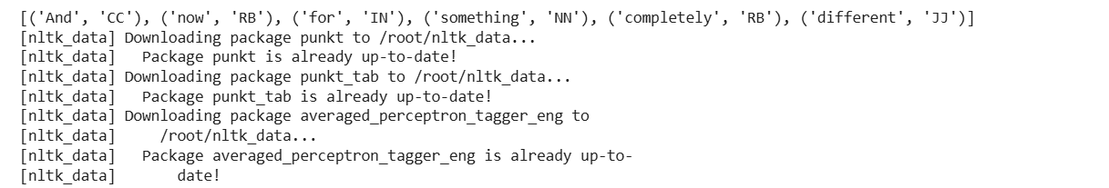

import nltk
nltk.download('brown')
text = nltk.Text(word.lower() for word in nltk.corpus.brown.words())
text.similar('woman')
text.similar('bought')
text.similar('over')
text.similar('the')
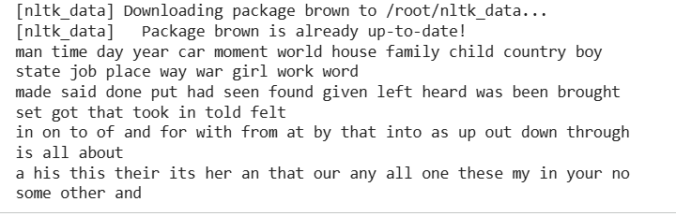
Tagged Corpora
tagged_token = nltk.tag.str2tuple('fly/NN')
print(tagged_token)
print(tagged_token[0])
print(tagged_token[1])

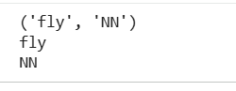
import nltk
sent ="""
The/AT grand/JJ jury/NN commented/VBD on/IN a/AT number/NN of/IN
other/AP topics/NNS,/, AMONG/IN them/PPO the/AT Atlanta/NP and/CC
Fulton/NP-tl County/NN-tl purchasing/VBG departments/NNS which/WDT it/PPS
said/VBD/ ARE/BER well/QL operated/VBN and/CC follow/VB generally/RB
accepted/VBN practices/NNS which/WDT inure/VB to/IN the/AT best/JJT
interest/NN of/IN both/ABX governments/NNS ''/"."""
tagged_tokens = [nltk.tag.str2tuple(t) for t in sent.split()]
print(tagged_tokens)
import nltk
nltk.download('universal_tagset') # Download the universal tagset
# Using the default Brown corpus tagset
tagged_words_default = nltk.corpus.brown.tagged_words()
print(tagged_words_default)
# Using the Universal Tagset for the Brown corpus
tagged_words_universal = nltk.corpus.brown.tagged_words(tagset='universal')
print(tagged_words_universal)
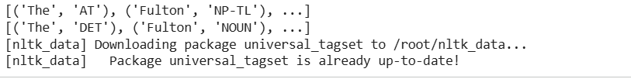

import nltk
nltk.download('nps_chat')
nltk.download('conll2000')
nltk.download('treebank')
# Access tagged words from the NPS Chat corpus
nps_chat_tagged_words = nltk.corpus.nps_chat.tagged_words()
print(nps_chat_tagged_words)
# Access tagged words from the CoNLL 2000 corpus
con112000_tagged_words = nltk.corpus.conll2000.tagged_words()
print(con112000_tagged_words)
# Access tagged words from the Treebank corpus
treebank_tagged_words = nltk.corpus.treebank.tagged_words()
print(treebank_tagged_words)
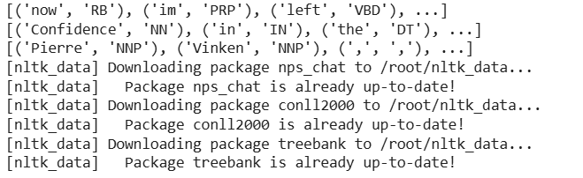

import nltk
# Access tagged words from the Brown corpus with the Universal Tagset
brown_tagged_words_universal = nltk.corpus.brown.tagged_words(tagset='universal')
print(brown_tagged_words_universal)
# Access tagged words from the Treebank corpus with the Universal Tagset
treebank_tagged_words_universal = nltk.corpus.treebank.tagged_words (tagset='universal')
print(treebank_tagged_words_universal)

import nltk
nltk.download('sinica_treebank')
nltk.download('indian')
nltk.download('mac_morpho')
nltk.download('conll2002') # Corrected from conl12002
nltk.download('cess_cat')
# Access tagged words from the Sinica Treebank corpus
sinica_treebank_tagged_words = nltk.corpus.sinica_treebank.tagged_words()
print(sinica_treebank_tagged_words)
# Access tagged words from the Indian corpus
indian_tagged_words = nltk.corpus.indian.tagged_words()
print(indian_tagged_words)
# Access tagged words from the Mac-Morpho corpus
mac_morpho_tagged_words = nltk.corpus.mac_morpho.tagged_words()
print(mac_morpho_tagged_words)
# Access tagged words from the CoNLL 2002 corpus
con112002_tagged_words = nltk.corpus.conll2002.tagged_words()
print(con112002_tagged_words)
# Access tagged words from the CESS-CAT corpus
cess_cat_tagged_words = nltk.corpus.cess_cat.tagged_words()
print(cess_cat_tagged_words)

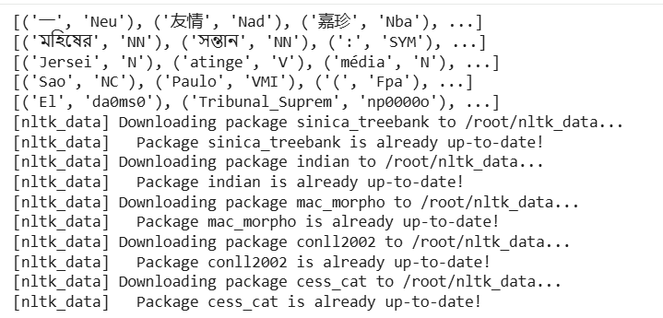
from nltk.corpus import brown
brown_news_tagged = brown.tagged_words (categories='news', tagset='universal')
tag_fd = nltk.FreqDist(tag for (word, tag) in brown_news_tagged)
tag_fd.most_common()
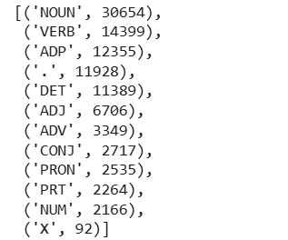

# Load the Brown corpus and filter it to use only the 'news' category
brown_news_tagged = nltk.corpus.brown.tagged_words (categories='news')
# Generate bigrams from the tagged words in the 'news' category
word_tag_pairs = nltk.bigrams (brown_news_tagged)
# Filter for cases where the second item in the bigram is tagged as a noun ('NOUN')
noun_preceders = [a[1] for (a, b) in word_tag_pairs if b[1] == 'NOUN']
# Create a frequency distribution of the tags that precede nouns
fdist = nltk.FreqDist(noun_preceders)
# Extract the most common tags that precede nouns
most_common_tags = [tag for (tag, _) in fdist.most_common()]
print (most_common_tags)
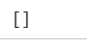

import nltk
# Access tagged words from the Treebank corpus with the Universal Tagset
wsj = nltk.corpus.treebank.tagged_words (tagset='universal')
# Create a frequency distribution of word-tag pairs
word_tag_fd = nltk.FreqDist(wsj)
# Extract the most common words tagged as verbs
verbs = [wt[0] for (wt, _) in word_tag_fd.most_common() if wt[1] == 'VERB']
print(verbs)

import nltk

# Assuming 'wsj' contains the Wall Street Journal portion of the Treebank corpus
# If 'wsj' is not defined yet, load the Wall Street Journal portion of the Treebank corpus
wsj = nltk.corpus.treebank.tagged_words()
# Create a ConditionalFreqDist object
cfd1 = nltk.ConditionalFreqDist(wsj)
# Check the distribution of parts of speech for the word 'yield'
yield_pos_distribution = cfd1['yield'].most_common()
print("Distribution of 'yield':", yield_pos_distribution)
# Check the distribution of parts of speech for the word
cut_pos_distribution = cfd1['cut'].most_common()
print("Distribution of 'cut':", cut_pos_distribution)

import nltk
# Assuming 'wsj' contains the Wall Street Journal portion of the Treebank corpus
# If 'wsj' is not defined yet, load the Wall Street Journal portion of the Treebank corpus
wsj = nltk.corpus.treebank.tagged_words()
# Create a ConditionalFreqDist object by swapping word and tag positions
cfd2 = nltk.ConditionalFreqDist((tag, word) for (word, tag) in wsj)
# List words tagged as 'VBN' (past participle)
vbn_words = list(cfd2['VBN'])
print(vbn_words[:20]) # Display the first 20 words for brevity

import nltk
# Assuming 'wsj' contains the Wall Street Journal portion of the Treebank corpus
# If 'wsj' is not defined yet, load the Wall Street Journal portion of the Treebank corpus
wsj = nltk.corpus.treebank.tagged_words()
# Create a ConditionalFreqDist object 'cfd1'
cfd1 = nltk.ConditionalFreqDist((word, tag) for (word, tag) in wsj)
# Find words that are tagged as both 'VBD' (past tense) and 'VBN' (past participle)
words_with_vbd_and_vbn = [w for w in cfd1.conditions() if 'VBD' in cfd1[w] and 'VBN' in cfd1[w]]
print(words_with_vbd_and_vbn[:10]) # Display the first 10 words for brevity
# Find context surrounding 'kicked' as 'VBD'
idx1 = wsj.index(('kicked', 'VBD'))
print(wsj[idx1-4:idx1+1])
# Find context surrounding 'kicked' as 'VBN'
idx2 = wsj.index(('kicked', 'VBN'))
print(wsj[idx2-4:idx2+1])
import nltk
def findtags (tag_prefix, tagged_text):
cfd = nltk.ConditionalFreqDist((tag, word) for (word, tag) in tagged_text
if tag.startswith(tag_prefix))
return {tag: cfd[tag].most_common(5) for tag in cfd.conditions()}
tagged_news = nltk.corpus.brown.tagged_words (categories='news')
tagdict = findtags('NN', tagged_news)
for tag in sorted(tagdict):
print(tag, tagdict[tag])
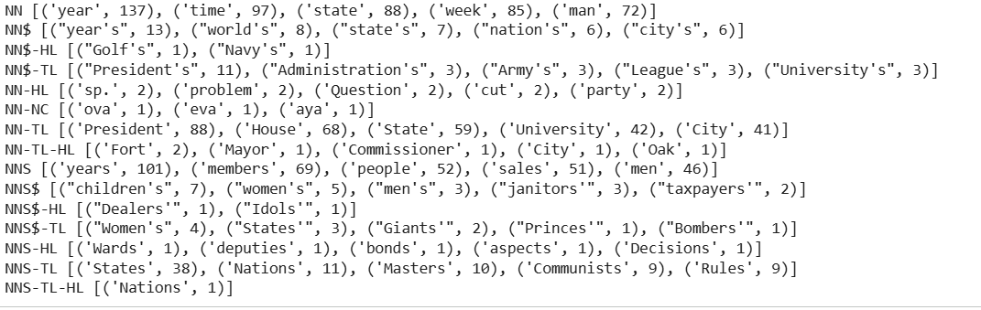

import nltk
# Assuming 'brown_learned_text' contains the words from the 'learned' category of the Brown corpus
brown_learned_text = nltk.corpus.brown.words (categories='learned')
# Find words that occur after 'often' in the 'learned' category of the Brown corpus
words_after_often = sorted(set(b for (a, b) in nltk.bigrams (brown_learned_text) if a == 'often'))
print(words_after_often)

brown_lrnd_tagged = brown.tagged_words(categories='learned', tagset='universal')
tags = [b[1] for (a, b) in nltk.bigrams(brown_lrnd_tagged) if a[0] == 'often']
fd = nltk.FreqDist(tags)
fd.tabulate()
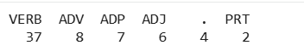

from nltk.corpus import brown
import nltk
def process (sentence):
for (w1, t1), (w2, t2), (w3, t3) in nltk.trigrams(sentence):
if t1.startswith('V') and t2 == 'TO' and t3.startswith('V'):
print(w1, w2, w3)
# Iterate through tagged sentences in the Brown corpus and apply the 'process' function
for tagged_sent in brown.tagged_sents():
process (tagged_sent)
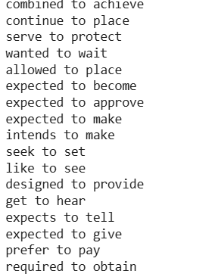
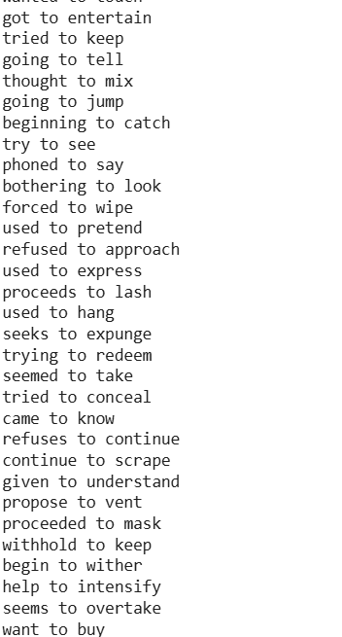

from nltk.corpus import brown
import nltk
# Extract tagged words from the 'news' category of the Brown corpus using the Universal Tagset
brown_news_tagged = brown.tagged_words (categories='news', tagset='universal')
# Create a ConditionalFreqDist object based on the tagged words
data = nltk.ConditionalFreqDist((word.lower(), tag) for (word, tag) in brown_news_tagged)
# Iterate through words in sorted order and print words with more than three different tags
for word in sorted(data.conditions()):
if len(data[word]) > 3:
tags = [tag for (tag, _) in data[word].most_common()]
print(word,''.join(tags))

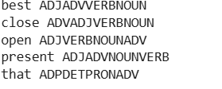
pos = {} # Creating an empty dictionary named 'pos'
pos['colorless'] = 'ADJ' # Adding 'colorless' with the tag 'ADJ' to the dictionary
pos['ideas'] = 'N' # Adding 'ideas' with the tag 'N' to the dictionary
pos['sleep'] = 'V' # Adding 'sleep' with the tag 'V' to the dictionary
pos['furiously'] = 'ADV' # Adding 'furiously' with the tag 'ADV' to the dictionary
pos
pos['ideas']
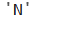

pos['colorless']
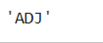
list(pos) # [1]
sorted(pos) # [2]
[w for w in pos if w.endswith('s')]

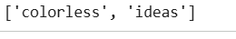
for word in sorted(pos):
print(word + ":", pos [word])
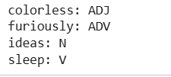

pos = {
'colorless': 'ADJ',
'ideas': 'N',
'sleep': 'V',
'furiously': 'ADV'
}
# Retrieving and displaying keys, values, and items from the 'pos' dictionary
print(list(pos.keys())) # Retrieve keys
print(list(pos.values())) # Retrieve values
print(list(pos.items())) # Retrieve key-value pairs
# Iterating through sorted key-value pairs and printing them
for key, val in sorted(pos.items()):
print (key + ":", val)
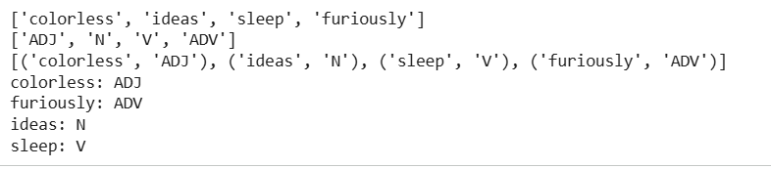

pos['sleep'] = 'V'
pos['sleep']

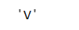
pos['sleep'] = 'N'
pos['sleep']
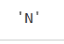

pos = {'colorless': 'ADJ', 'ideas': 'N', 'sleep': 'V', 'furiously': 'ADV'}
pos = dict(colorless='ADJ', ideas='N', sleep='V', furiously='ADV')
from collections import defaultdict
frequency = defaultdict(int)
frequency['colorless'] = 4
frequency['ideas'] # Accessing a key that doesn't exist defaults to 0

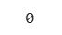

from collections import defaultdict
pos = defaultdict(list)
pos ['sleep'] = ['NOUN', 'VERB']
pos['ideas'] # Accessing a key that doesn't exist defaults to an empty list
# Output: [ ]

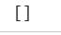
from collections import defaultdict
pos = defaultdict(lambda: 'NOUN') # [1]
pos['colorless'] = 'ADJ'
pos['blog'] # [2]
# Output: 'NOUN'
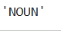

list(pos.items())

import nltk
from collections import defaultdict
nltk.download('gutenberg') # Download the gutenberg corpus
# Load the text and create a frequency distribution of words
alice = nltk.corpus.gutenberg.words('carroll-alice.txt')
vocab = nltk.FreqDist(alice)
# Select the 1000 most common words
v1000 = [word for (word, _) in vocab.most_common (1000)]
# Create a mapping dictionary to replace less common words with 'UNK'
mapping = defaultdict(lambda: 'UNK')
for v in v1000:
mapping[v] = v
# Transform the original text, replacing less common words with 'UNK'
alice2 = [mapping[v] for v in alice]
# Display the initial 100 transformed words
print(alice2[:100])
# Determine the number of unique tokens after transformation
print(len(set(alice2)))

from collections import defaultdict
from nltk.corpus import brown
from operator import itemgetter
counts = defaultdict(int)
for (word, tag) in brown.tagged_words(categories='news', tagset='universal'):
counts [tag] += 1
counts ['NOUN']
sorted(counts)
sorted (counts.items(), key=itemgetter(1), reverse=True)
[t for t, c in sorted(counts.items(), key=itemgetter(1), reverse=True)]

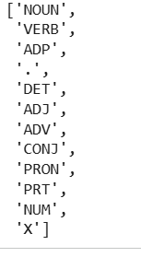
pair = ('NP', 8336)
pair[1]
itemgetter(1)(pair)

from collections import defaultdict
import nltk
nltk.download('words') # Download the 'words' corpus
last_letters = defaultdict(list)
words = nltk.corpus.words.words('en')
for word in words:
key = word[-2:]
last_letters [key].append (word)
last_letters['ly']
last_letters['zy']

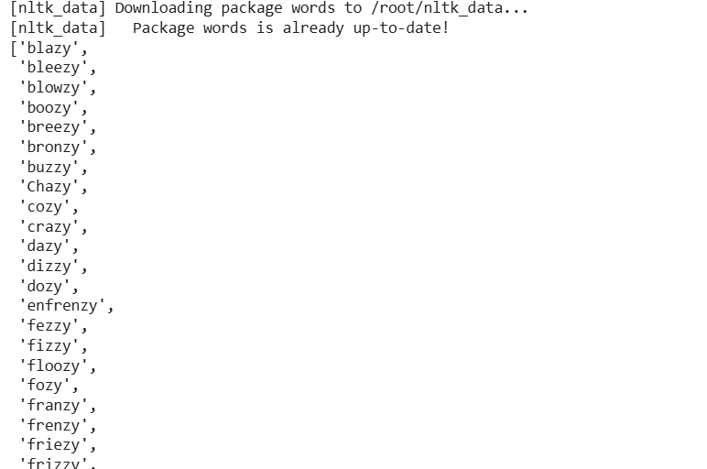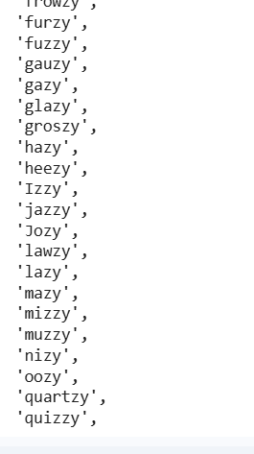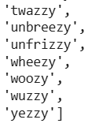
from collections import defaultdict
import nltk
anagrams = defaultdict(list)
words = nltk.corpus.words.words('en')
for word in words:
key =''.join(sorted(word))
anagrams [key].append (word)
anagrams ['aeilnrt']

import nltk
words = nltk.corpus.words.words('en')
anagrams = nltk.Index((''.join(sorted(w)), w) for w in words)
anagrams ['aeilnrt']

from collections import defaultdict
import nltk
pos = defaultdict(lambda: defaultdict(int))
brown_news_tagged = brown.tagged_words (categories='news', tagset='universal')
for ((w1, t1), (w2, t2)) in nltk.bigrams (brown_news_tagged):
pos[(t1, w2)][t2] += 1
pos [('DET', 'right')]
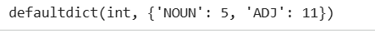

from collections import defaultdict
import nltk
counts = defaultdict(int)
for word in nltk.corpus.gutenberg.words('milton-paradise.txt'):
counts [word] += 1
[word for (word, count) in counts.items() if count == 32]
# Output: ['brought', 'Him', 'virtue', 'Against', 'There', 'thine', 'King', 'mortal', 'every', 'been']

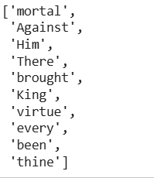
pos = {'colorless': 'ADJ', 'ideas': 'N', 'sleep': 'V', 'furiously': 'ADV'}
pos2 = dict((value, key) for (key, value) in pos.items())
pos2['N']
# Output: 'ideas'

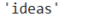
from collections import defaultdict
# NLP_LAB5.ipynb - Colaboratory
pos = {'colorless': 'ADJ', 'ideas': 'N', 'sleep': 'V', 'furiously': 'ADV'}
pos.update({'cats': 'N', 'scratch': 'V', 'peacefully': 'ADV','old': 'ADJ'})
pos2 = defaultdict(list)
for key, value in pos.items():
pos2[value].append(key)
pos2['ADV'];
import nltk
pos = {'colorless': 'ADJ', 'ideas': 'N', 'sleep': 'V', 'furiously': 'ADV'}
pos.update({'cats': 'N', 'scratch': 'V', 'peacefully': 'ADV', 'old': 'ADJ'})
pos2 = nltk.Index((value, key) for (key, value) in pos.items())
pos2['ADV']
# Output: ['peacefully', 'furiously']
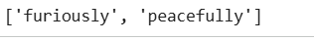

from nltk.corpus import brown
#Fetching tagged sentences from the 'news' category in the Brown corpus
brown_tagged_sents = brown.tagged_sents (categories='news')
# Fetching untagged sentences from the 'news' category in the Brown corpus
brown_sents = brown.sents(categories='news')
tags = [tag for (word, tag) in brown.tagged_words (categories='news')]
nltk.FreqDist (tags).max()

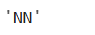
raw = 'I do not like green eggs and ham, I do not like them Sam I am!'
tokens = nltk.word_tokenize(raw)
default_tagger = nltk.DefaultTagger('NN')
default_tagger.tag (tokens)
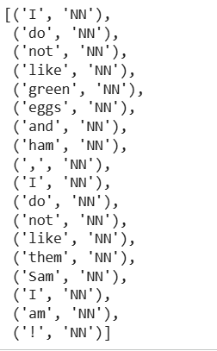

default_tagger.evaluate(brown_tagged_sents)
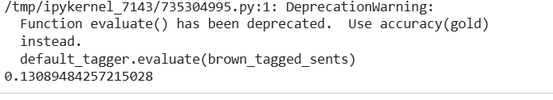

patterns = [
(r'.*ing$', 'VBG'), # gerunds
# simple past
# 3rd singular present
# modals
(r'.*ed$', 'VBD'),
(r'.*es$', 'VBZ'),
(r'.*ould$', 'MD'),
(r'.*\'s$', 'NN$'),
(r'.*s$', 'NNS'),
(r'^-?[0-9]+(\.[0-9]+)?$', 'CD'), # cardinal numbers
(r'.*', 'NN') # nouns (default)
# possessive nouns
# plural nouns
]
regexp_tagger = nltk.RegexpTagger (patterns)
regexp_tagger.tag(brown_sents [3])

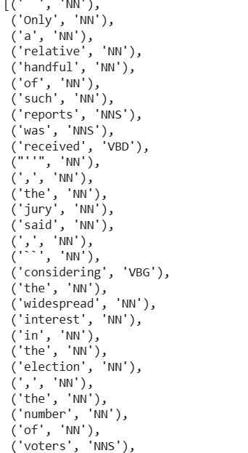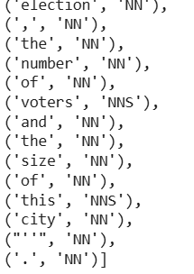
regexp_tagger.evaluate (brown_tagged_sents)

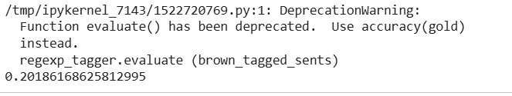
import nltk
fd = nltk.FreqDist(brown.words (categories='news'))
cfd = nltk.ConditionalFreqDist(brown.tagged_words (categories='news'))
most_freq_words = fd.most_common (100)
likely_tags = dict((word, cfd[word].max()) for (word, _) in most_freq_words)
baseline_tagger = nltk.UnigramTagger (model=likely_tags)
baseline_tagger.evaluate(brown_tagged_sents)

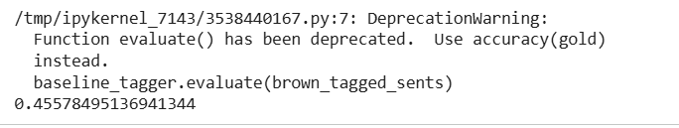
import nltk
sent = brown.sents (categories='news') [3]
baseline_tagger.tag(sent)

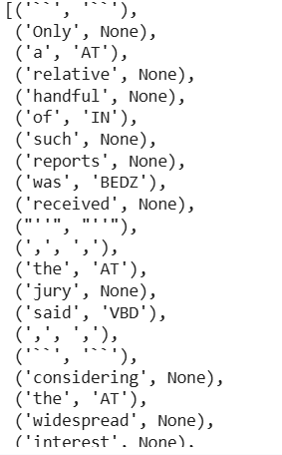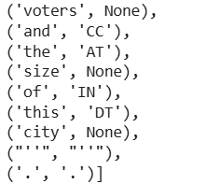
import nltk
baseline_tagger = nltk.UnigramTagger (model=likely_tags, backoff=nltk.DefaultTagger('NN'))
def performance(cfd, wordlist):
lt = dict((word, cfd[word].max()) for word in wordlist)
baseline_tagger = nltk.UnigramTagger (model=lt, backoff=nltk.DefaultTagger('NN'))
return baseline_tagger.accuracy(brown.tagged_sents (categories='news')) # Changed evaluate() to accuracy()
def display():
import pylab
word_freqs = nltk.FreqDist(brown.words (categories='news')).most_common()
words_by_freq = [w for (w, _) in word_freqs]
cfd = nltk.ConditionalFreqDist(brown.tagged_words (categories='news'))
sizes = 2 ** pylab.arange(15)
perfs = [performance(cfd, words_by_freq[:size]) for size in sizes]
pylab.plot(sizes, perfs, '-bo')
pylab.title('Lookup Tagger Performance with Varying Model Size')
pylab.xlabel('Model Size')
pylab.ylabel('Performance')
pylab.show()
display()
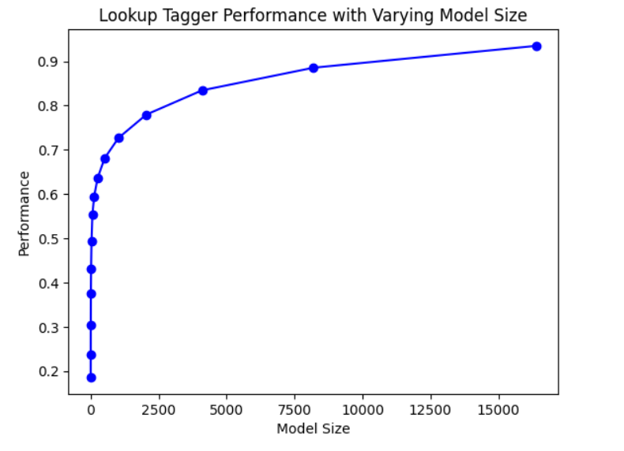

from nltk.corpus import brown
brown_tagged_sents = brown.tagged_sents (categories='news')
brown_sents = brown.sents(categories='news')
unigram_tagger = nltk.UnigramTagger (brown_tagged_sents)
unigram_tagger.tag(brown_sents [2007])
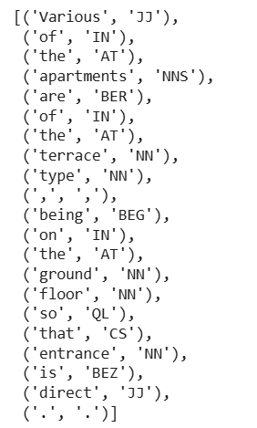
unigram_tagger.evaluate(brown_tagged_sents)
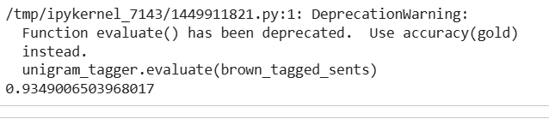

size = int(len(brown_tagged_sents) * 0.9)
train_sents = brown_tagged_sents[:size]
test_sents = brown_tagged_sents[size:]
unigram_tagger = nltk.UnigramTagger(train_sents)
unigram_tagger.evaluate(test_sents)

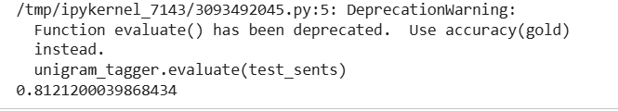
bigram_tagger = nltk.BigramTagger(train_sents)
bigram_tagger.tag(brown_sents [2007])

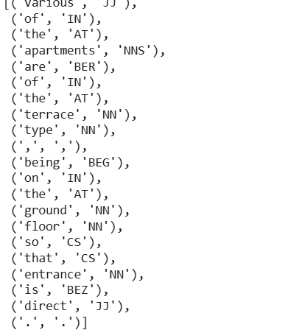

unseen_sent = brown_sents [4203]
bigram_tagger.tag(unseen_sent)

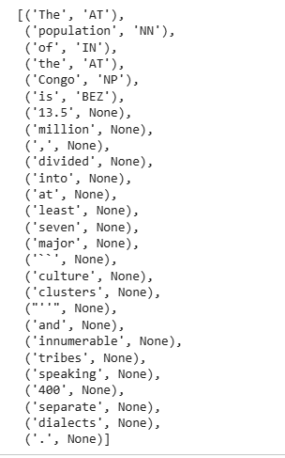
bigram_tagger.evaluate(test_sents)

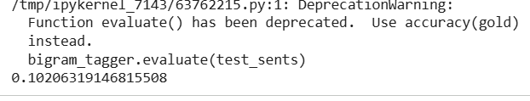
t0 = nltk.DefaultTagger('NN')
t1 = nltk.UnigramTagger(train_sents, backoff=t0)
t2 = nltk.BigramTagger(train_sents, backoff=t1)
t2.evaluate(test_sents)

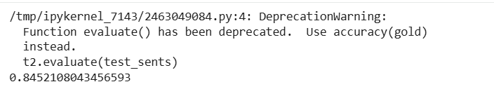

from pickle import dump
output = open('t2.pkl', 'wb')
dump(t2, output, -1)
output.close()
from pickle import load
input_file = open('t2.pkl', 'rb')
tagger = load(input_file)
input_file.close()
text = """The board's action shows what free enterprise
is up against in our complex maze of regulatory laws."""
tokens = text.split()
tagger.tag(tokens)

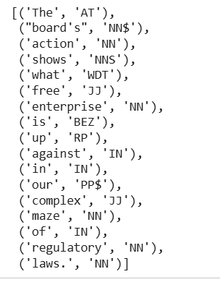

cfd = nltk.ConditionalFreqDist(
((x[1], y[1], z[0]), z[1])
for sent in brown_tagged_sents
for x, y, z in nltk.trigrams(sent))
ambiguous_contexts = [c for c in cfd.conditions() if len(cfd[c]) > 1]
sum(cfd[c].N() for c in ambiguous_contexts) / cfd.N()
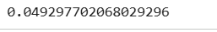

test_tags = [tag for sent in brown.sents(categories='editorial')
for (word, tag) in t2.tag(sent)]
gold_tags = [tag for (word, tag) in brown.tagged_words(categories='editorial')]
print(nltk.ConfusionMatrix(gold_tags, test_tags))

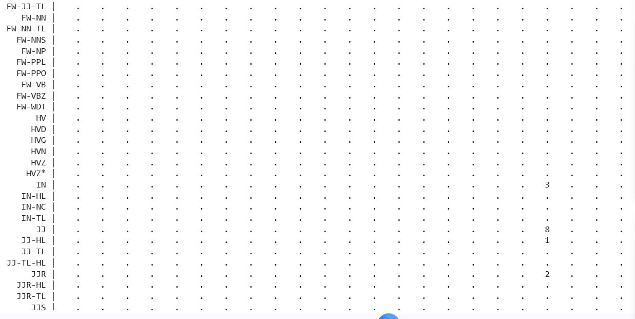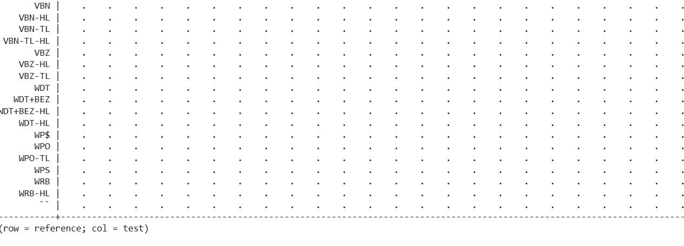
from nltk.tbl import demo as brill_demo
brill_demo.demo()
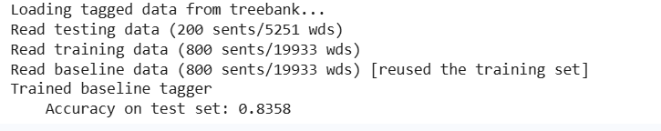

EXPERIMENT-6
HMM(Hidden Markov Model) - POS Tagging Algorithm

import nltk, re, pprint
import numpy as np
import pandas as pd
import requests
import matplotlib.pyplot as plt
import seaborn as sns
import pprint, time
import random
from sklearn.model_selection import train_test_split
from nltk.tokenize import word_tokenize

nltk.download('treebank') # Download the 'treebank' corpus
nltk.download('universal_tagset') # Download the 'universal_tagset' resource

# reading the Treebank tagged sentences
wsj = list(nltk.corpus.treebank.tagged_sents(tagset='universal'))

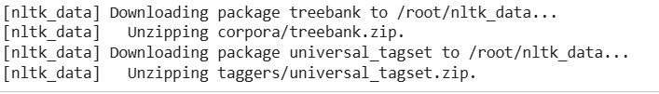

print(wsj[:40])
random.seed (1234)
train_set, test_set = train_test_split(wsj,test_size=0.05)
print(len(train_set))
print(len(test_set))
print(train_set[:40])
train_tagged_words = [tup for sent in train_set for tup in sent]
len(train_tagged_words)
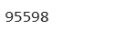
tokens = [pair[0] for pair in train_tagged_words]
tokens [:10]
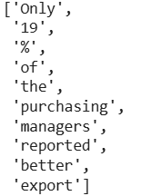
V = set(tokens)
print(len(V))
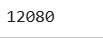

T = set([pair[1] for pair in train_tagged_words])
len(T)
print(T)

HMM(Hidden Markov Model) - POS Tagging Algorithm Emission Probabilities
t = len(T)
v = len(V)
w_given_t = np.zeros((t, v))
# compute word given tag: Emission Probability
def word_given_tag(word, tag, train_bag = train_tagged_words):
tag_list = [pair for pair in train_bag if pair[1]==tag]
count_tag = len(tag_list)
w_given_tag_list = [pair[0] for pair in tag_list if pair[0]==word]
count_w_given_tag = len(w_given_tag_list)
return (count_w_given_tag, count_tag)
# examples
# large
print("\n", "large")
print(word_given_tag('large', 'ADJ'))
print(word_given_tag('large', 'VERB'))
print(word_given_tag('large', 'NOUN'), "\n")
# will
print("\n", "will")
print(word_given_tag('will', 'MD'))
print(word_given_tag('will', 'NOUN'))
print(word_given_tag('will', 'VERB'))
# book
print("\n", "book")
print(word_given_tag('book', 'NOUN'))
print(word_given_tag('book', 'VERB'))
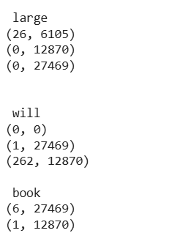
word_given_tag('Twitter', 'NOUN')
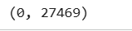
Transisition Probabilities
def t2_given_t1(t2, t1, train_bag = train_tagged_words):
tags = [pair[1] for pair in train_bag]
count_t1 = len([t for t in tags if t==t1])
count_t2_t1 = 0
for index in range(len(tags)-1):
if tags[index]==t1 and tags[index+1] == t2:
count_t2_t1 += 1
return (count_t2_t1, count_t1)

# examples
print(t2_given_t1(t2='NOUN', t1='ADJ'))
print(t2_given_t1('ADJ', 'NOUN'))
print(t2_given_t1('NOUN', 'DET'))
print(t2_given_t1('NOUN', 'VERB'))
print(t2_given_t1(',', 'NOUN'))
print(t2_given_t1('PRT', 'PRT'))
print(t2_given_t1('VERB', 'NOUN'))
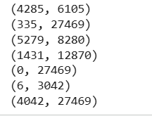

#Please note P(tag|start) is same as P(tag|'.')
print(t2_given_t1('DET', '.'))
print(t2_given_t1('VERB', '.'))
print(t2_given_t1('NOUN', '.'))
print(t2_given_t1('NOUN', '.'))
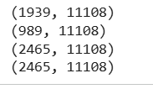
t2_given_t1('VERB', 'DET')

# creating txt transition matrix of tags
# each column is t2, each row is t1
# thus M(i, j) represents P(tj given ti)
tags_matrix = np.zeros((len(T), len(T)), dtype='float32')
for i, t1 in enumerate(list(T)):
for j, t2 in enumerate(list(T)):
tags_matrix[i, j] = t2_given_t1(t2, t1)[0]/t2_given_t1(t2, t1)[1]
tags_matrix
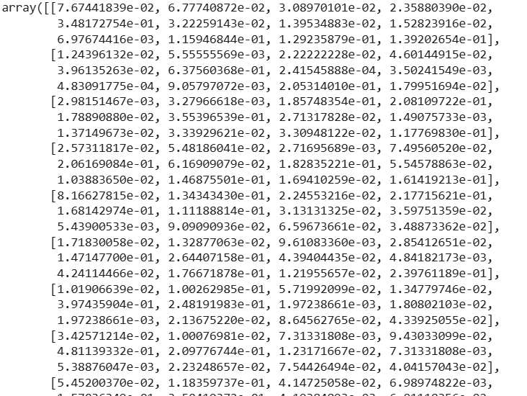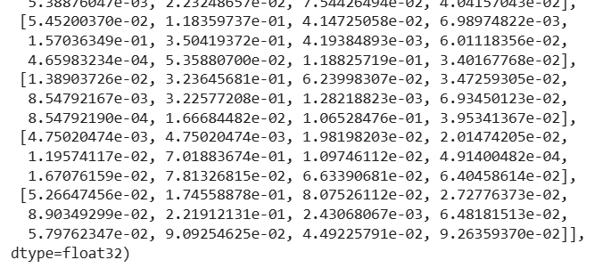

# convert the matrix to a df for better readability
tags_df = pd.DataFrame(tags_matrix, columns = list(T), index=list(T))
tags_df

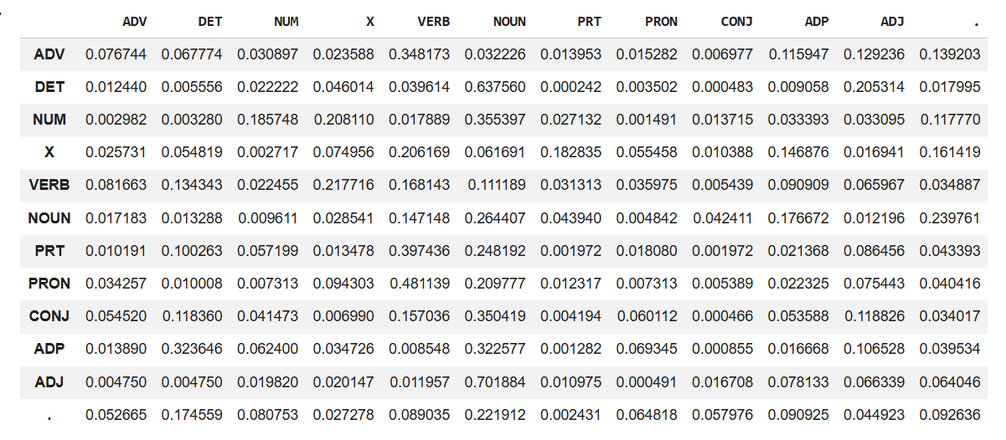
tags_df.loc['.', :]
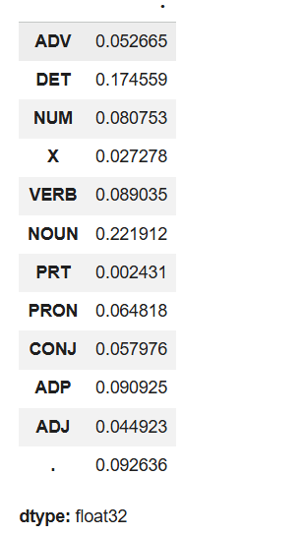

Heat Map of Tags Matrix

# T(i, j) means P(tag j given tag i)
plt.figure(figsize=(18, 12))
sns.heatmap(tags_df)
plt.show()

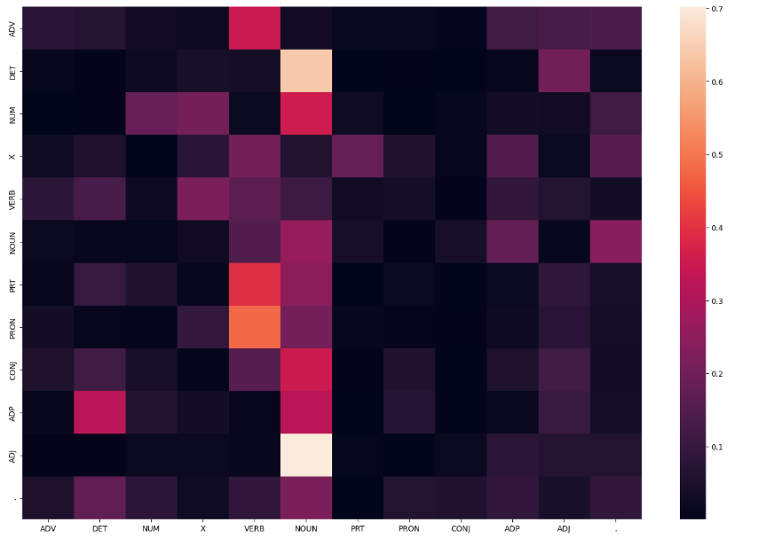
# frequent tags
# filter the df to get P(t2, t1) > 0.5
tags_frequent = tags_df[tags_df>0.5]
plt.figure(figsize=(18, 12))
sns.heatmap(tags_frequent)
plt.show()
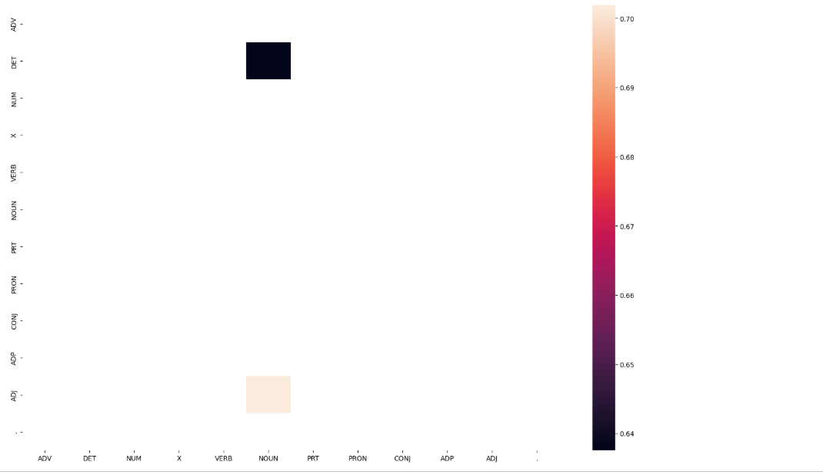
Vanilla Viterbi
def Viterbi_vanilla(words, train_bag = train_tagged_words):
state = []
T = list(set([pair[1] for pair in train_bag]))
for key, word in enumerate(words):
#initialise list of probability column for a given observation
p = []
for tag in T:
if key == 0:
transition_p = tags_df.loc['.', tag]
else:
transition_p = tags_df.loc[state[-1], tag]
# compute emission and state probabilities
emission_p = word_given_tag(words [key], tag)[0]/word_given_tag(words[key], tag) [1]
state_probability = emission_p * transition_p
p.append(state_probability)
#print('word is {} and list is {}'.format(word,p))
pmax = max(p)
# getting state for which probability is maximum
state_max = T[p.index(pmax)]
state.append(state_max)
return list(zip(words, state))

Vanilla Laplace smoothened

def Viterbi_smoothed(words, train_bag = train_tagged_words):
state = []
T = list(set([pair[1] for pair in train_bag]))
for key, word in enumerate(words):
#initialise list of probability column for a given observation
p = []
for tag in T:
if key == 0:
transition_p = tags_df.loc['.', tag]
else:
transition_p = tags_df.loc[state[-1], tag]
# compute emission and state probabilities
emission_p = 0.000001+word_given_tag(words [key], tag)[0]/word_given_tag(words [key], tag) [1]+0.000001*len(T)
state_probability = emission_p * transition_p
p.append(state_probability)
#print('word is {} and list is {}'.format(word,p))
pmax = max(p)
# getting state for which probability is maximum
state_max = T[p.index(pmax)]
state.append(state_max)
return list(zip(words, state))

Viterbi with RegExp for unknown words

def find_state(word):
#punc=['"',"'",',','.','(',')','?','[',']',':',';']
# xc=['*'] # This was likely intended for the X tag logic below, but not needed as a separate list.
if re.search(r'.*(ing|ed|es|ould)$', word.lower()):
return 'VERB'
elif re.search(r'to$', str(word).lower()):
return 'PRT'
elif re.search(r'^-?[0-9]+(\.[0-9]+)?$', str(word).lower()):
return 'NUM'
elif '*' in word:
return 'X'
elif re.search(r'.*\'s$', word.lower()):
return 'NOUN'
elif re.search(r'.*ness$', word.lower()):
return 'NOUN'
elif re.search(r'(The|the|A|a|An|an)$', word):
return 'DET'
elif re.search(r'.*able$', word.lower()):
return 'ADJ'
elif re.search(r'.*ly$', word.lower()):
return 'ADV'
# NLP_LAB6.ipynb - Colaboratory
elif re.search(r'(He|he|She|she|It|it|I|me|Me|You|you|His|his|Her|her|Its|its|my|Your
|your|Yours|yours)$', word):
return 'PRON'
elif re.search(r'(on|On|at|At|since|Since|For|for|Ago|ago|before|Before|till|Till|until|Until|by|By
|Beside|beside|under|Under|below|Below)', word):
return 'ADP'
#elif re.search(r'', word): # This condition is always true and should be removed or made more specific
# return 'NOUN'
#elif re.search(r'(\']"]\.[\S\[\[\?[\S\[\[\][\:[\;)+', word): # Invalid regex, commenting out
# pass
else:
# Default tag, if no other rule matches
return 'NOUN'

def Viterbi_manual(words, train_bag = train_tagged_words):
state = []
T = list(set([pair[1] for pair in train_bag]))
for key, word in enumerate(words):
#initialise list of probability column for a given observation
p= []
for tag in T:
if key == 0:
transition_p = tags_df.loc['.', tag]
else:
transition_p = tags_df.loc[state[-1], tag]
# compute emission and state probabilities
emission_p = word_given_tag(words[key], tag)[0]/word_given_tag(words [key], tag) [1]
state_probability = emission_p * transition_p
p.append(state_probability)
#print('word is {} and list is {}'.format(word,p))
pmax = max(p)
if pmax == 0.0:
state_word = find_state(word)
state.append(state_word)
else:
# getting state for which probability is maximum
state_max = T[p.index(pmax)]
state.append(state_max)
return list(zip(words, state))

Viterbi for unknown words given mostly used tag

def Viterbi_common(words, train_bag = train_tagged_words):
state = []
T = list(set([pair[1] for pair in train_bag]))
for key, word in enumerate(words):
#initialise list of probability column for a given observation
p = []
for tag in T:
if key == 0:
# This part is missing a calculation for the initial probability
# For now, let's assume a default small value or handle it later
transition_p = tags_df.loc['.', tag]
else:
transition_p = tags_df.loc[state[-1], tag]
# compute emission and state probabilities
if word in tokens:
emission_p = word_given_tag(words[key], tag)[0]/word_given_tag(words[key], tag)[1]
else:
emission_p=1 # Assign a default emission probability for unknown words
state_probability = emission_p * transition_p
p.append(state_probability)
#print('word is {} and list is {}'.format(word,p))
pmax = max(p)
if pmax==0.0:
# If no probability found, assign a common tag, e.g., 'NOUN'
state_word='NOUN'
state.append(state_word)
else:
#print(word,':', state_word)
# getting state for which probability is maximum
state_max = T[p.index(pmax)]
state.append(state_max)
return list(zip(words, state))

def Viterbi(words, train_bag = train_tagged_words):
state = []
T = list(set([pair[1] for pair in train_bag]))
for key, word in enumerate(words):
#initialise list of probability column for a given observation
p = []
for tag in T:
if key == 0:
transition_p = tags_df.loc['.', tag]
else:
transition_p = tags_df.loc[state[-1], tag]
# compute emission and state probabilities
if word in tokens:
emission_p = word_given_tag(words[key], tag)[0]/word_given_tag(words [key], tag) [1]
else:
emission_p=1
state_probability = emission_p * transition_p
p.append(state_probability)
#print('word is {} and list is {}'.format(word,p))
pmax = max(p)
# getting state for which probability is maximum
state_max = T[p.index(pmax)]
state.append(state_max)
return list(zip(words, state))

Testing our model on Vanilla Viterbi

import time

# tagging the test sentences
start = time.time ()
tagged_seq_vanilla = Viterbi_vanilla(test_tagged_words)
check = [i for i, j in zip(tagged_seq_vanilla, test_run_base) if i == j]
accuracy = len(check)/len(tagged_seq_vanilla)
end = time.time()
print('Time Taken:',end-start)
print('Accuracy is :',accuracy)
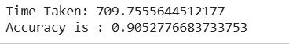

Testing model on Viterbi Laplace smoothened

start = time.time()
tagged_seq_smooth = Viterbi_smoothed(test_tagged_words)
check = [i for i, j in zip(tagged_seq_smooth, test_run_base) if i == j]
accuracy = len(check)/len(tagged_seq_smooth)
end = time.time()
print('Time Taken:',end-start)
print('Accuracy is :',accuracy)
print('Laplace smoothed Viterbi-Incorrect tagged cases are:')
incorrect_tagged_cases = [[test_run_base[i-1],j] for i, j in enumerate(zip(tagged_seq_smooth, test_run_base)) if j[0]!=j[1]]
[i[1]for i in incorrect_tagged_cases]

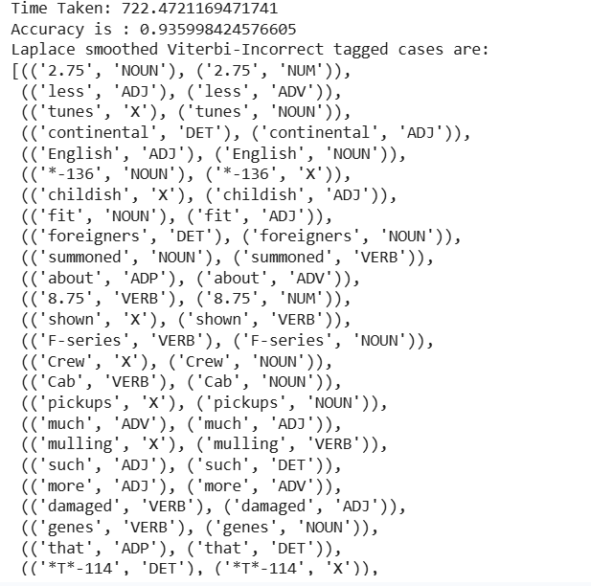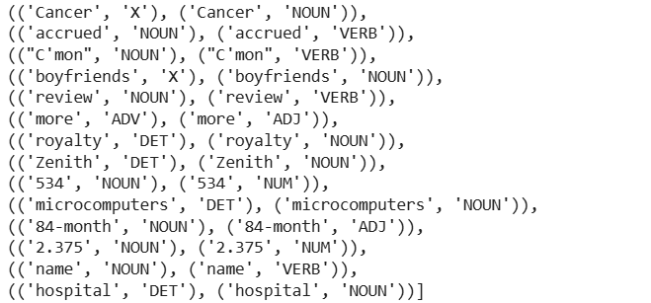
Testing model on modified Viterbi with morphological cues (Best model)

start = time.time()
tagged_seq_sm = Viterbi_manual(test_tagged_words)
check = [i for i, j in zip(tagged_seq_sm, test_run_base) if i == j]
accuracy = len(check)/len(tagged_seq_sm)
end = time.time()
print('Time Taken:',end-start)
print('Accuracy is:',accuracy)
print('Laplace smoothed Viterbi-Incorrect tagged cases are:')
incorrect_tagged_cases = [[test_run_base[i-1],j] for i, j in enumerate(zip(tagged_seq_sm, test_run_base)) if j[0]!=j[1]]
[i[1]for i in incorrect_tagged_cases]
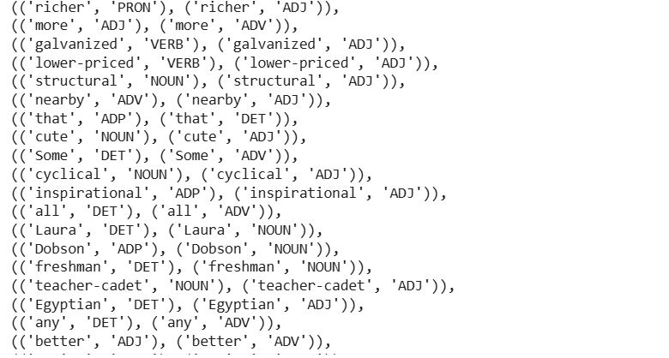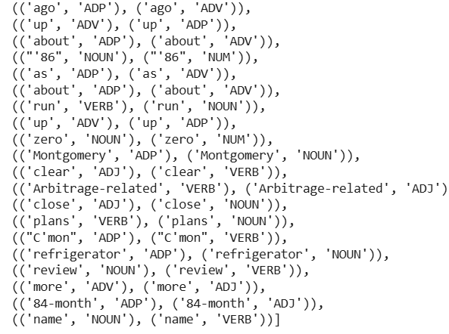

Testing model on viterbi with unknown word given mostly used tag

start = time.time()
tagged_seq_co = Viterbi_common(test_tagged_words)
check = [i for i, j in zip(tagged_seq_co, test_run_base) if i == j]
accuracy = len(check)/len(tagged_seq_co)
end = time.time()
print('Time Taken:',end-start)
print('Accuracy is :',accuracy)
print('Laplace smoothed Viterbi-Incorrect tagged cases are:')
incorrect_tagged_cases = [[test_run_base[i-1],j] for i, j in enumerate(zip(tagged_seq_co, test_run_base)) if j[0]!=j[1]]
[i[1]for i in incorrect_tagged_cases]
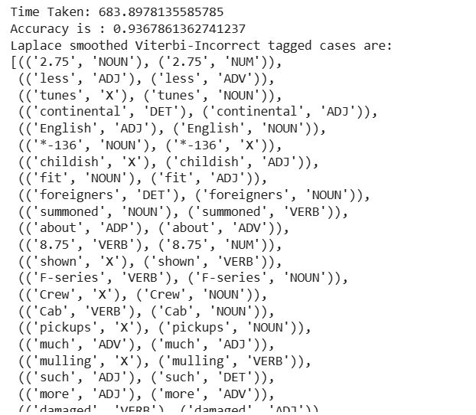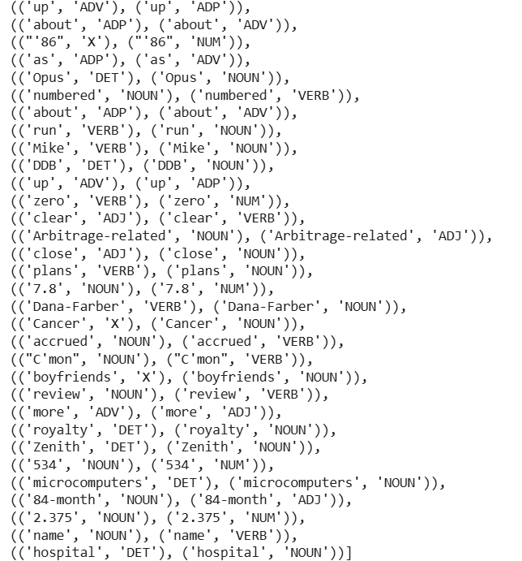
Testing model on Viterbi choosing only transisition probability in case emission probability is zero
start = time.time()
tagged_seq_t = Viterbi(test_tagged_words)
check = [i for i, j in zip(tagged_seq_t, test_run_base) if i == j]
accuracy = len(check)/len(tagged_seq_t)
end = time.time()
print('Time Taken:',end-start)
print('Accuracy is :',accuracy)
print('Laplace smoothed Viterbi-Incorrect tagged cases are:')
incorrect_tagged_cases = [[test_run_base[i-1],j] for i, j in enumerate(zip(tagged_seq_t, test_run_base)) if j[0]!=j[1]]
[i[1]for i in incorrect_tagged_cases]
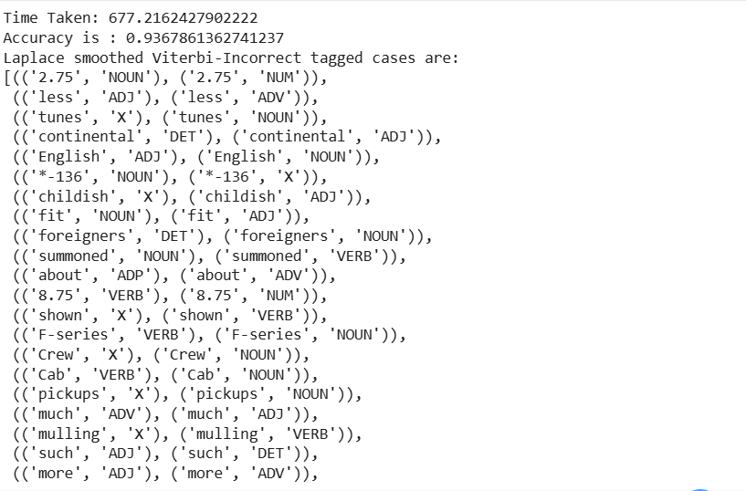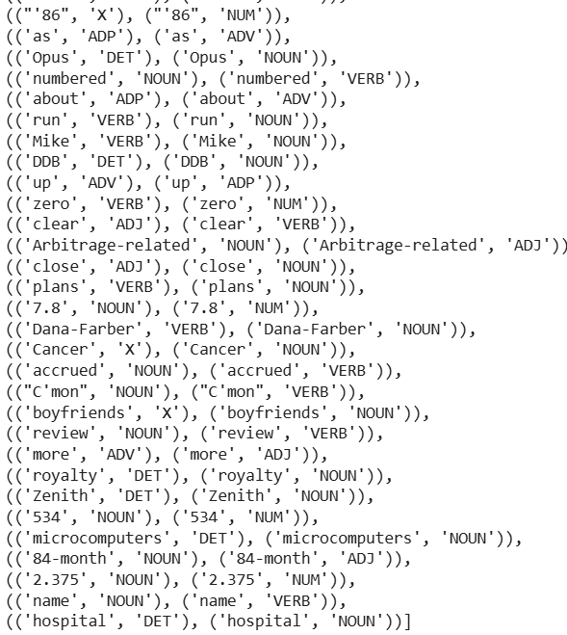

Finding Incorrect tagged cases in vanilla Viterbi algorigtm which are corrected in other models

incorrect_tagged_cases = [j for i, j in enumerate(zip(tagged_seq_vanilla, test_run_base)) if j[0]!=j[1]]
#inc2=[j[2] for i, j in enumerate(zip(test_run_base, tagged_seq_vanilla,tagged_seq_sm)) if (j[0]!=j[1])&(j[2][0]==j[1][0])]
pd.set_option('display.max_rows', None)
cor_word=pd.Series([i[1][0] for i in incorrect_tagged_cases])
cor_pos=pd.Series([i[1][1] for i in incorrect_tagged_cases])
inco=pd.Series([i[0][1] for i in incorrect_tagged_cases])
m2=[j[2] for i, j in enumerate(zip(test_run_base, tagged_seq_vanilla, tagged_seq_smooth)) if (j[0]!=j[1])&(j[2][0]==j[1][0])]
m2_pos=pd.Series([i[1] for i in m2])
m3=[j[2] for i, j in enumerate(zip(test_run_base, tagged_seq_vanilla,tagged_seq_sm)) if (j[0]!=j[1])&(j[2][0]==j[1][0])]
m3_pos=pd.Series([i[1] for i in m3])
m4=[j[2] for i, j in enumerate(zip(test_run_base, tagged_seq_vanilla,tagged_seq_co)) if (j[0]!=j[1])&(j[2][0]==j[1][0])]
m4_pos=pd.Series([i[1] for i in m4])
m5=[j[2] for i, j in enumerate(zip(test_run_base,tagged_seq_vanilla,tagged_seq_t)) if (j[0]!=j[1])&(j[2][0]==j[1][0])]
m5_pos=pd.Series([i[1] for i in m5])
df=pd.DataFrame (cor_word,columns=['Word'])
df.set_index('Word')
df['Correct_POS']=cor_pos
df['Model1_Viterbi_Vanilla']=inco
df['Model2_Laplace']=m2_pos
df['Mode13 Morphological']=m3_pos
df['Model4_MostTagBased']=m4_pos
df['Mode15_onlyTransistion']=m5_pos
df.drop_duplicates()
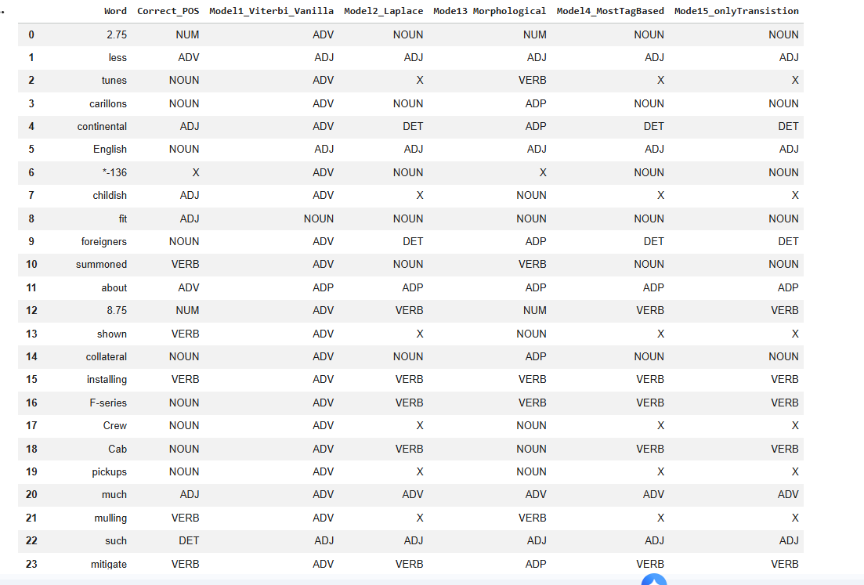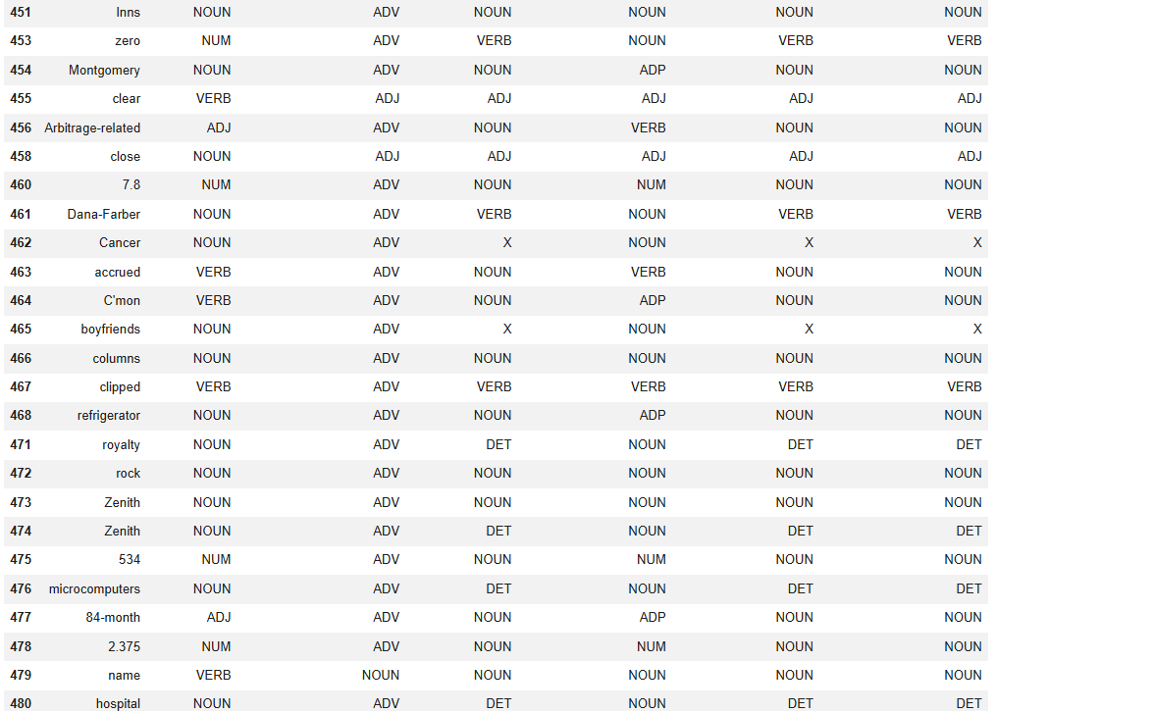

EXPERIMENT-7
Cocke-Kasami-Younger (CYK)
!pip install binarytree

import itertools
from tabulate import tabulate
import math
from collections import defaultdict
import numpy as np
from binarytree import Node
#Class for grammar rule
class Rule:
def __init__ (self, left, right, prob = 0):
self.left = left
self.right = right
self.prob = prob
# NLP_LAB7.ipynb - Colaboratory
# Class grammer that holds the rule
class Grammar:
def __init__ (self, rules):
self.grammar = {}
self.reversed_grammar = {}
for rule in rules:
self.grammar[rule.left] = self.grammar.get(rule.left, set()).union(set([rule.right]))
#self.reversed_grammar[rule.right] = self.reversed_grammar.get(rule.right, set()).union(str(rule.left) + "##" + str(rule.prob))
if rule.right not in self.reversed_grammar:
self.reversed_grammar[rule.right] = defaultdict(int)
self.reversed_grammar[rule.right][str(rule.left) + "##" + str(rule.prob)] += 1
# Custom Class for binary tree. It inherites the 'Node' class of binarytree package. This is useful to visualise a tree data structure
class TreeNode (Node):
def __init__ (self, value, log_prob, left, right, word=None):
value = value if word is None else f"{value}-{word}"
super().__init__ (value, left, right)
# Calculate the log_score using left, right tree
left_score = 0 if self.left is None else self.left.score
right_score = 0 if self.right is None else self.right.score
self.score = log_prob + left_score + right_score
# Calculate probability
self.prob = math.exp(self.score)
def __repr__ (self):
return str(round(self.prob, 4))
# Calculates a marginal probability of trees
def marginalize_trees (trees):
if not trees:
return 0
prob = sum([tree.prob for tree in trees])
return prob
class CKYParser(Grammar):
# initialize parser
def __init__ (self, rules):
super().__init__ (rules)
# cky parser algorithm
def parse(self, words):
# initialize table

table = [[""] * i + [set()] * (len(words) - i) for i in range(len(words))]
#
for j in range(len(words)): # iterate of the columns
cell = set()
for word_tag in self.reversed_grammar.get(words[j], {}):
w, p = word_tag.split('##')
cell.add (w)
# initialize diagonal element
table[j][j] = cell
# fill up the rows from bottom to up
for i in reversed(range(j)):
cell = set()
for k in range(i, j):
rows = table[i] [k]
cols = table[k + 1][j]
permutations = list(itertools.product(rows, cols))
# iterate on each permutation
for left, right in permutations:
check = f"{left} {right}"
if check in self.reversed_grammar.keys():
cell = cell.union([k.split('##') [0] for k in self.reversed_grammar[check]])
# update cell value
table[i][j] = cell if len(cell)>0 else 'Φ'
return table
# weighted cky parser algorithm
def weigheted_parse(self, words):
# initialize table
table = [[""] * i + [set()] * (len(words) - i) for i in range(len(words))]
tree_list = list()
# iterate of the columns
for j in range(len(words)):
cell = set()
for word_tag in self.reversed_grammar.get(words[j], {}):
w, p = word_tag.split('##')
p = float (p)
node = TreeNode(w, np.log(p), left=None, right=None, word=words [j])
cell.add((w, node))
# initialize diagonal element
table[j][j] = cell
# fill up the rows from bottom to up
for i in reversed(range(j)):
cell = set()
for k in range(i, j):
rows = table[i] [k]
cols = table[k + 1][j]
permutations = list(itertools.product(rows, cols))
# iterate on each permutation
for left, right in permutations:
l_const, l_node = left
r_const, r_node = right
check = f"{l_const} {r_const}"
if check in self.reversed_grammar.keys():
for k_rule in self.reversed_grammar[check]:
w, p = k_rule.split('##')
p = float(p)
new_node = TreeNode(w, np.log(p), left=l_node, right=r_node)
cell.add((w, new_node))
table[i][j] = cell
# Only add trees that have the root node as the start symbol(S)
for tag, root in table[0][-1]:
if tag == "S":
tree_list.append(root)
return table, tree_list
# NLP_LAB7.ipynb - Colaboratory
sentence = "British left waffles on Falklands"
tokens = sentence.split(" ")
rules = [Rule("S", "NP VP"), Rule("NP", "JJ NP"), Rule("VP", "VP NP"), Rule("VP", "VP PP"), Rule("PP", "P NP"), Rule("NP", "British")] # Added closing bracket for rules list
# Missing rule definitions in the original, adding placeholders for demonstrative purposes
rules.extend([
Rule("JJ", "British"), Rule("VP", "left"), Rule("NP", "waffles"), Rule("P", "on"), Rule("NP", "Falklands"),
Rule("NP", "left"), Rule("VP", "waffles")
])
cky_parser = CKYParser (rules)
table = cky_parser.parse(tokens)
print("CKY Table:")
print()
print(tabulate(table, headers=tokens, showindex="always"))

# The output provided in the original notebook snippet is not Python code but rendered table. Ignoring that for now.
# CKY Table:
# British left waffles on Falklands
# 0{'NP', יככי'} S' 'NP'} {'S'} Φ {'S'}
# 1 {'VP' 'NP' {'VP', t'S. Φ {'S', 'VP'}
# 2 {'VP', 'NP'} Φ {'VP'}
# {'P'} {'PP'}
# 4 {'NP'}
sentence = "astronomers saw stars with ears"
tokens = sentence.split(" ")
# The original code has an incomplete rule definition at the end `Rule(`. Closing it with a placeholder rule.
rules = [Rule("S", "NP VP", 1.0), Rule("PP", "P NP", 1.0), Rule("VP", "V NP", 0.7), Rule("VP", "VP PP", 0.3), Rule("P", "with", 1.0)]
rules.extend([
Rule("NP", "astronomers", 0.5), Rule("NP", "stars", 0.5), Rule("NP", "ears", 0.5),
Rule("V", "saw", 1.0)
])
cky_parser = CKYParser(rules)
table, parse_trees = cky_parser.weigheted_parse (tokens)
print("Weighted CKY Table:")
print()
print(tabulate(table, headers=tokens, showindex="always"))
print()
# best tree
best_tree = max(parse_trees, key=lambda node: node.score)
print("Most Probable Parse Tree:")
print()
print('Score:', best_tree.prob)
print(best_tree)
print()
# Marginalize over all trees
print(f"Probability of Sentence marginalized over the trees: {marginalize_trees(parse_trees)}")

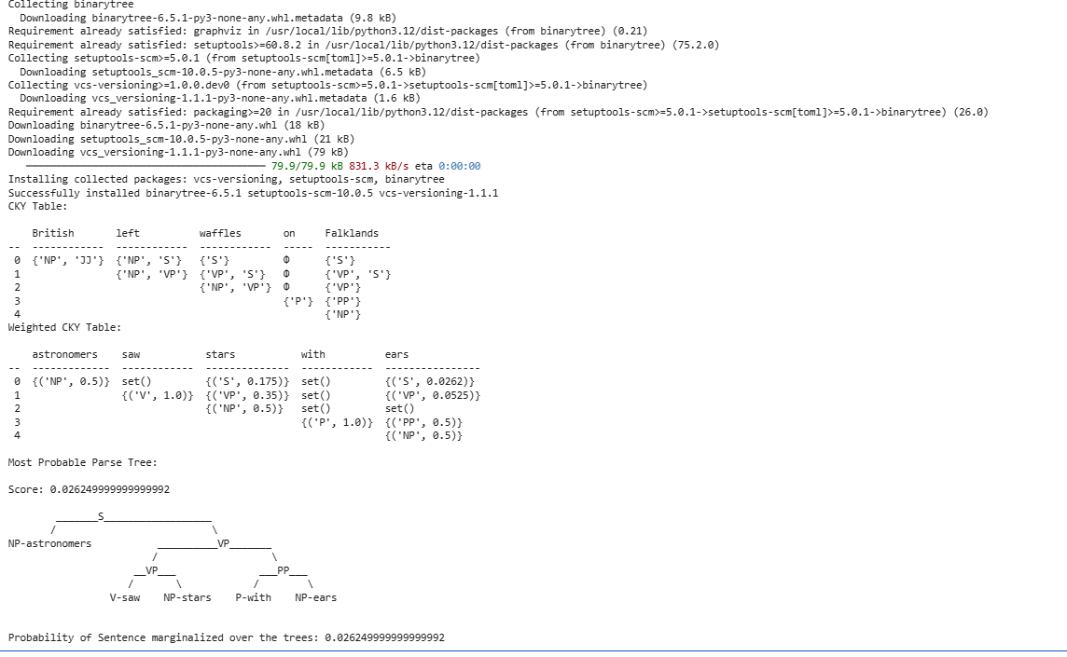

EXPERIMENT-8
Minimum Edit Distance Method
def min_edit_distance(str1, str2):
len_str1 = len(str1) + 1
len_str2 = len(str2) + 1
# Create a matrix to store minimum edit distances
matrix = [[0 for _ in range(len_str2)] for _ in range(len_str1)]
# Initialize the matrix with distances for the first row and column
for i in range(len_str1):
matrix[i][0] = i
for j in range(len_str2):
matrix[0][j] = j
# Fill in the matrix with minimum edit distances
for i in range(1, len_str1):
for j in range(1, len_str2):
cost = 0 if str1[i - 1] == str2[j - 1] else 1
matrix[i][j] = min(
matrix[i - 1][j] + 1, # Deletion
matrix[i][j - 1] + 1, # Insertion
matrix[i - 1][j - 1] + cost # Substitution
)
return matrix[len_str1 - 1][len_str2 - 1]

def correct_spelling(word, candidate_words):
# Find the word in the candidate list with the minimum edit distance
min_distance = float('inf')
corrected_word = ""
for candidate in candidate_words:
distance = min_edit_distance(word, candidate)
if distance < min_distance:
min_distance = distance
corrected_word = candidate
return corrected_word, min_distance

# Example usage:
input_word = "happee" # Replace this with the word you want to correct
candidate_words = ["happy", "happier", "happiness", "happening", "hippie"]
corrected_word, distance = correct_spelling(input_word, candidate_words)
print(f"Original word: {input_word}")
print(f"Corrected spelling: {corrected_word}")
print(f"Minimum edit distance: {distance}")

